

Appropriation Act (No. 3) 1999-2000

No. 37, 2000

Appropriation Act (No. 3) 1999-2000

No. 37, 2000

An Act to appropriate additional money out of the Consolidated Revenue Fund for the service of the year ending on 30 June 2000, and for related purposes

Contents
Part 1—Preliminary 1
1 Short title 1
2 Commencement 2
3 Definitions 2
4 Notional payments, receipts etc. 3
Part 2—Basic appropriations 4
5 Summary of basic appropriations 4
6 Departmental items—basic appropriation 4
7 Administered items—basic appropriation 5
Part 3—Additions to basic appropriations 6
8 Net appropriations 6
9 Departmental items—adjustments 6
10 Advance to the Finance Minister—unforeseen expenditure etc. 6
11 Comcover receipts 7
Part 4—Miscellaneous 8
12 Crediting amounts to Special Accounts 8
13 Appropriation of the Consolidated Revenue Fund 8
Schedule - Services for which money is appropriated 9

Appropriation Act (No. 3) 1999-2000
No. 37, 2000

An Act to appropriate additional money out of the Consolidated Revenue Fund for the service of the year ending on 30 June 2000, and for related purposes
[Assented to 3 May 2000]

The Parliament of Australia enacts:

Part 1—Preliminary

1 Short title
This Act may be cited as the Appropriation Act (No. 3) 1999-2000.

2 Commencement
This Act commences on the day on which it receives the Royal Assent.

3 Definitions
In this Act, unless the contrary intention appears:
administered item means an amount set out in the Schedule opposite an outcome of an entity under the heading “Administered Expenses”.
Agency has the same meaning as in the Financial Management and Accountability Act 1997.
Agency Minister, in relation to an Agency, means the Minister responsible for the Agency.
Chief Executive has the same meaning as in the Financial Management and Accountability Act 1997.
Commonwealth authority has the same meaning as in the Commonwealth Authorities and Companies Act 1997.
Commonwealth company has the same meaning as in the Commonwealth Authorities and Companies Act 1997.
current year means the financial year ending on 30 June 2000.
departmental item means the total amount set out in the Schedule in relation to an entity under the heading “Departmental Outputs”.
Note: The amounts set out opposite outcomes, under the heading “Departmental Outputs”, are “notional”. They are not part of the item, and do not in any way restrict the scope of the expenditure authorised by the item.
entity means any of the following:
(a) an Agency;
(b) a Commonwealth authority;
(c) a Commonwealth company.
Finance Minister means the Minister administering this Act.
item means an administered item or a departmental item.
Portfolio Additional Estimates Statements means the Portfolio Additional Estimates Statements that were tabled in the Senate or the House of Representatives in relation to the Bill for this Act and the Bill for the Appropriation Act (No. 4) 1999-2000.
Portfolio Budget Statements means the Portfolio Budget Statements that were tabled in the Senate or the House of Representatives in relation to the Bill for the Appropriation Act (No. 1) 1999-2000 and the Bill for the Appropriation Act (No. 2) 1999-2000.
section 31 agreement means an agreement under section 31 of the Financial Management and Accountability Act 1997.
Special Account has the same meaning as in the Financial Management and Accountability Act 1997.

4 Notional payments, receipts etc.
For the purposes of this Act, notional transactions between Agencies are to be treated as if they were real transactions.
Note: This section applies, for example, to a “payment” between Agencies that are both part of the Commonwealth. One of the effects of this section is that the payment will be debited from an appropriation for the paying Agency, even though no payment is actually made from the Consolidated Revenue Fund.

Part 2—Basic appropriations

5 Summary of basic appropriations
The total of the items specified in the Schedule is $1,846,754,000.
Note: Items in the Schedule can be increased under Part 3 of this Act and under section 11 of the Appropriation Act (No. 1) 1999-2000 (as modified by section 11 of this Act).

6 Departmental items—basic appropriation
(1) For a departmental item for an entity, the Finance Minister may issue out of the Consolidated Revenue Fund amounts that do not exceed, in total, the amount specified in the item.
Note: Generally, the Finance Minister is permitted, but not obliged, to issue the amounts out of the Consolidated Revenue Fund. However, subsections (3) and (4) impose an obligation on the Finance Minister to issue the amounts in certain circumstances.
(2) An amount issued out of the Consolidated Revenue Fund for a departmental item may only be applied for the departmental expenses, acquisition of assets or payment of liabilities, of the entity.
Note: The acquisition of new assets will usually be funded from a departmental capital item (in another Appropriation Act).
(3) If:
(a) an Act provides that an entity must be paid amounts that are appropriated by the Parliament for the purposes of the entity; and
(b) the Schedule contains a departmental item for that entity;
then the Finance Minister, under subsection (1), must issue out of the Consolidated Revenue Fund the full amount specified in the item.
(4) If a departmental item for an Agency includes provision for payment of remuneration and allowances to the holder of:
(a) a public office (within the meaning of the Remuneration Tribunal Act 1973); or
(b) an office specified in a Schedule to the Remuneration and Allowances Act 1990;
then the Finance Minister, under subsection (1), must issue out of the Consolidated Revenue Fund, under that item, amounts that are sufficient to pay the remuneration and allowances and must apply the amounts for that purpose.

7 Administered items—basic appropriation
(1) For an administered item for an outcome of an entity, the Finance Minister may issue out of the Consolidated Revenue Fund amounts that do not exceed, in total, the lesser of:
(a) the amount specified in the item; and
(b) the amount determined by the Finance Minister to be the administered expenses incurred by the entity in the current year in relation to the item.
(2) An amount issued out of the Consolidated Revenue Fund for an administered item for an outcome of an entity may only be applied for expenditure for the purpose of carrying out activities for the purpose of contributing to achieving that outcome.
Note: An administered item may be used to acquire assets. However, the acquisition of new assets will usually be funded from an administered capital item (in another Appropriation Act).
(3) If the Portfolio Additional Estimates Statements or Portfolio Budget Statements indicate that activities of a particular kind were intended to be treated as activities in respect of a particular outcome, then expenditure for the purpose of carrying out those activities is taken to be expenditure for the purpose of contributing to achieving the outcome.

Part 3—Additions to basic appropriations

8 Net appropriations
(1) If a section 31 agreement applies to a departmental item, then the amount specified in the item is taken to be increased in accordance with the agreement, and on the conditions set out in the agreement.
(2) For the purposes of section 31 of the Financial Management and Accountability Act 1997, each departmental item in the Schedule is taken to be marked “net appropriation”.
(3) If a section 31 agreement applies to an administered item, then the amount specified in the item is taken to be increased in accordance with the agreement, and on the conditions set out in the agreement.

9 Departmental items—adjustments
(1) The Finance Minister may determine that the amount specified in a departmental item is to be increased by an amount specified in the determination.
(2) The total of the amounts determined by the Finance Minister:
(a) under this section; and
(b) under section 9 of the Appropriation Act (No. 1) 1999-2000;
cannot be more than $20 million.
(3) The Finance Minister must give the Parliament details of increases made under this section.

10 Advance to the Finance Minister—unforeseen expenditure etc.
(1) This section applies if the Finance Minister is satisfied that:
(a) there is an urgent need for expenditure (for expenses, acquisition of assets or payment of liabilities) that is not provided for, or is insufficiently provided for, in the Schedule; and
(b) the additional expenditure is not provided for, or is insufficiently provided for, in the Schedule:
(i) because of an erroneous omission or understatement; or
(ii) because the additional expenditure was unforeseen until after the last day on which it was practicable to provide for it in the Bill for this Act before that Bill was introduced into the House of Representatives.
(2) This Act has effect as if the Schedule were amended, in accordance with a determination of the Finance Minister, to make provision for so much (if any) of the additional expenditure as the Finance Minister determines.
(3) The total of all the amounts determined by the Finance Minister:
(a) under this section; and
(b) under section 10 of the Appropriation Act (No. 1) 1999-2000;
cannot be more than $175 million.
(4) The Finance Minister must give the Parliament details of amounts determined under this section.

11 Comcover receipts
After the commencement of this Act, section 11 of the Appropriation Act (No. 1) 1999-2000 has effect as if the reference to an available item included a reference to:
(a) an item in the Schedule to this Act; and
(b) an item in Schedule 2 to the Appropriation Act (No. 4) 1999-2000.
Note: Section 11 of the Appropriation Act (No. 1) 1999-2000 provides for amounts to be added to available items for an Agency in respect of Comcover payments to the Agency.

Part 4—Miscellaneous

12 Crediting amounts to Special Accounts
If any of the purposes of a Special Account is a purpose that is covered by an item (whether or not the item expressly refers to the Special Account), then amounts may be debited against the appropriation for that item and credited to that Special Account.

13 Appropriation of the Consolidated Revenue Fund
The Consolidated Revenue Fund is appropriated as necessary for the purposes of this Act.
Schedule – Services for which money is appropriated
Note: See Sections 5 and 13
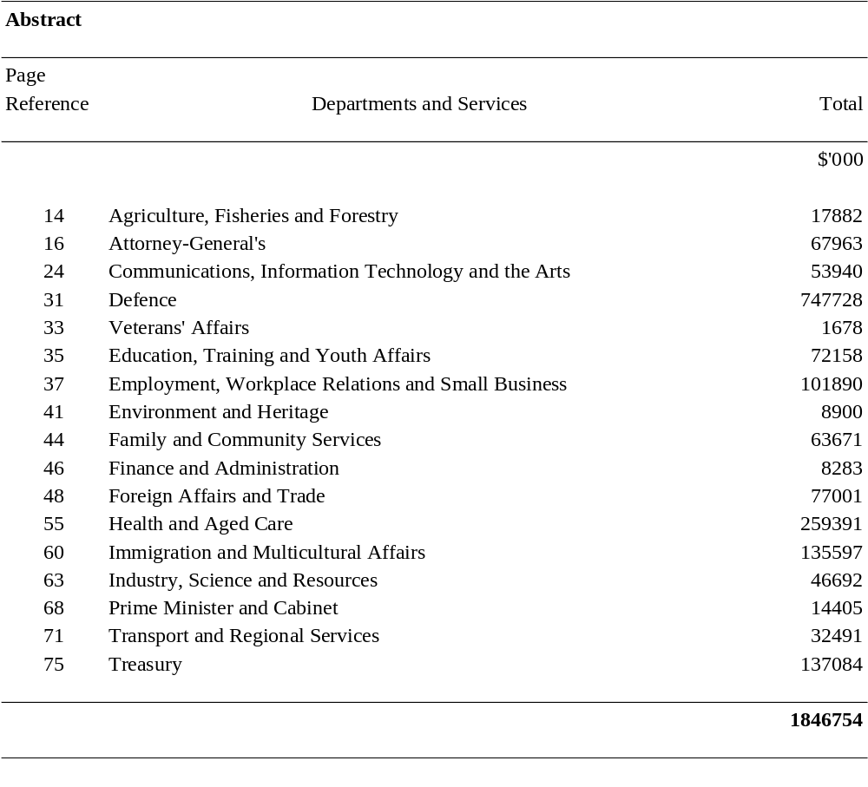

DEPARTMENTS AND SERVICES

SUMMARY
Additional Appropriation (bold figures) – 1999-2000
Budget Appropriation (italic figures) – 1999-2000

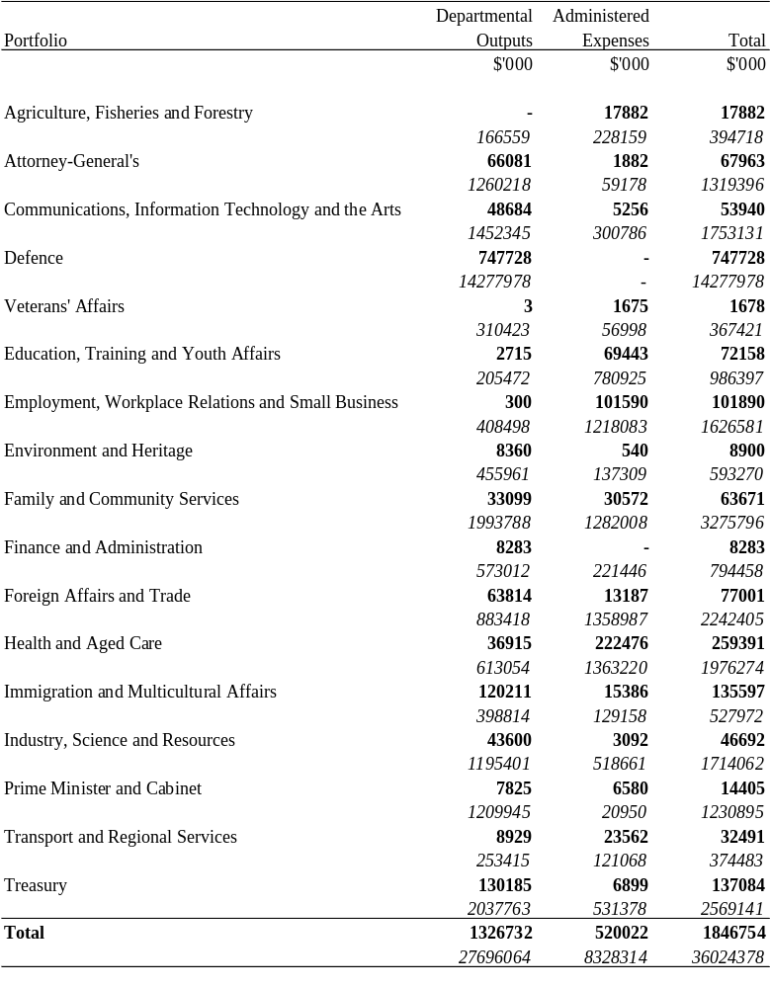

AGRICULTURE, FISHERIES AND FORESTRY PORTFOLIO

SUMMARY
Additional Appropriation (bold figures) – 1999-2000
Budget Appropriation (italic figures) – 1999-2000
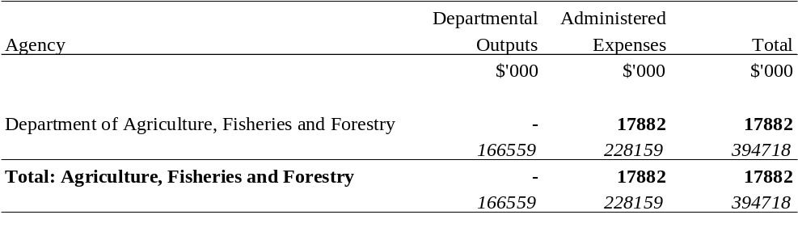

AGRICULTURE, FISHERIES AND FORESTRY PORTFOLIO
Additional Appropriation (bold figures) – 1999-2000
Budget Appropriation (italic figures) – 1999-2000
Estimated Expenses (light figures) – 1998-1999
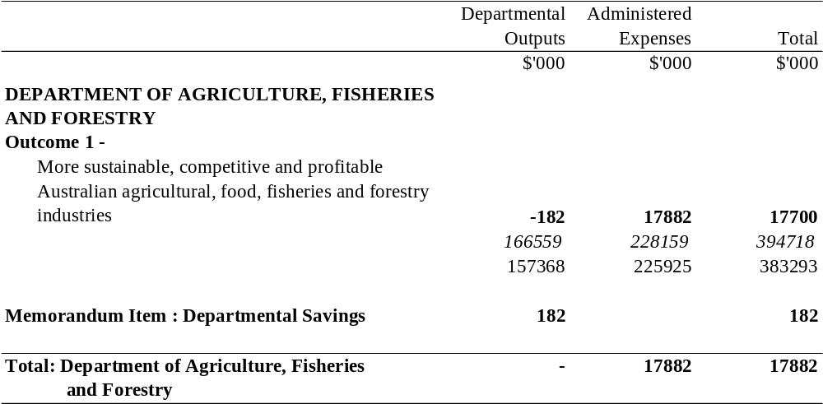
The Memorandum Item represents savings in departmental expenses consistent with the Statement of Savings document. Note that the amounts set out opposite outcomes, under the heading "Departmental Outputs", are notional. They do not form part of the total departmental appropriation item and do not in any way restrict the scope of the expenditure authorised by the item.

ATTORNEY-GENERAL’S PORTFOLIO

SUMMARY
Additional Appropriation (bold figures) – 1999-2000
Budget Appropriation (italic figures) – 1999-2000
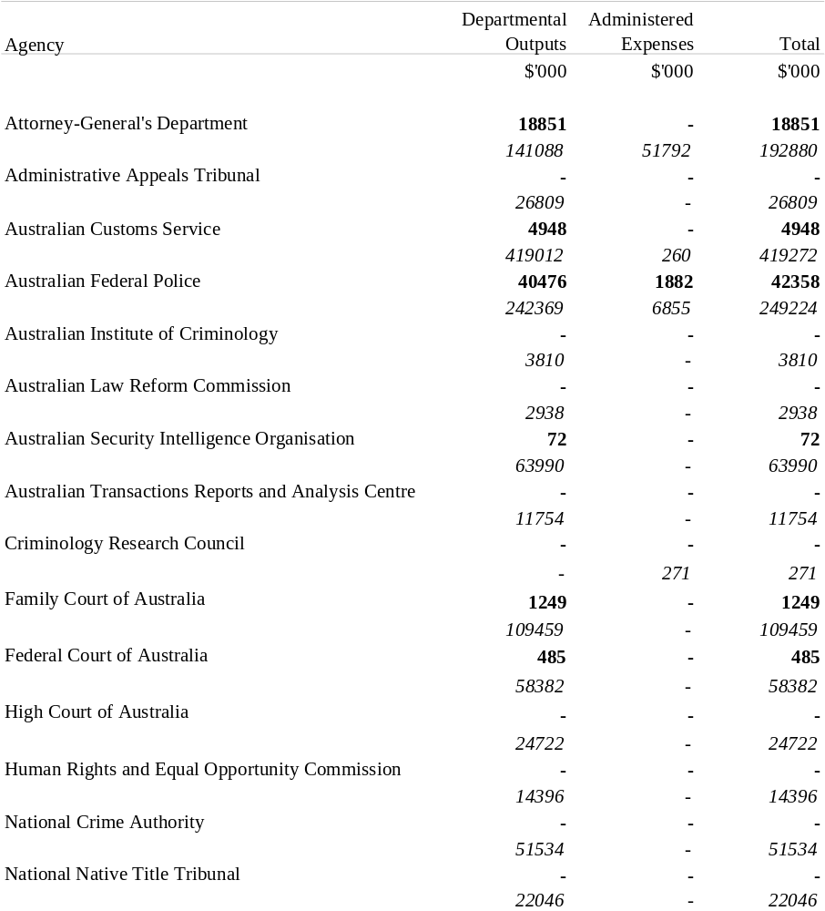

ATTORNEY-GENERAL’S PORTFOLIO

SUMMARY
Additional Appropriation (bold figures) – 1999-2000
Budget Appropriation (italic figures) – 1999-2000
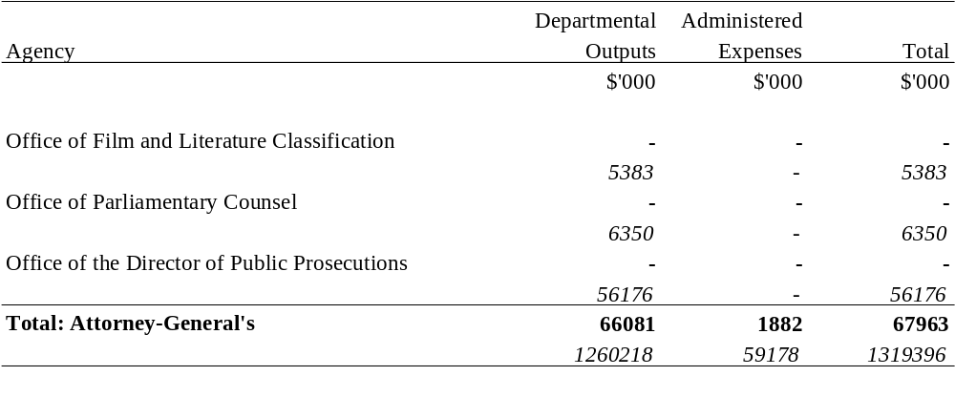

ATTORNEY-GENERAL’S PORTFOLIO
Additional Appropriation (bold figures) – 1999-2000
Budget Appropriation (italic figures) – 1999-2000
Estimated Expenses (light figures) – 1998-1999
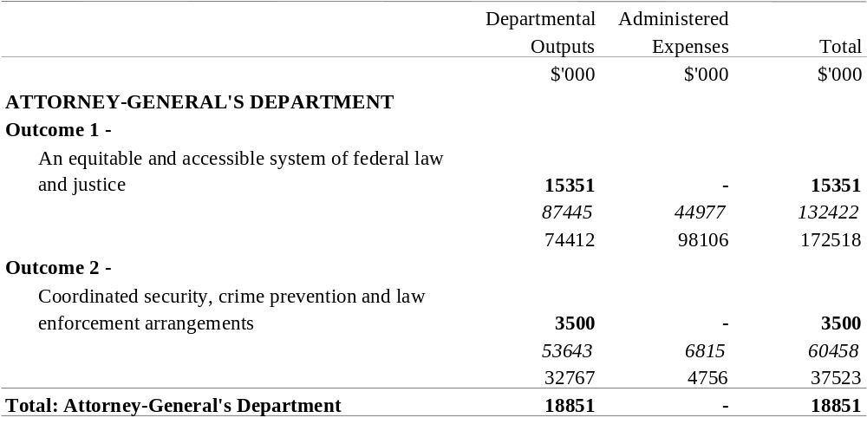

ATTORNEY-GENERAL’S PORTFOLIO
Additional Appropriation (bold figures) – 1999-2000
Budget Appropriation (italic figures) – 1999-2000
Estimated Expenses (light figures) – 1998-1999

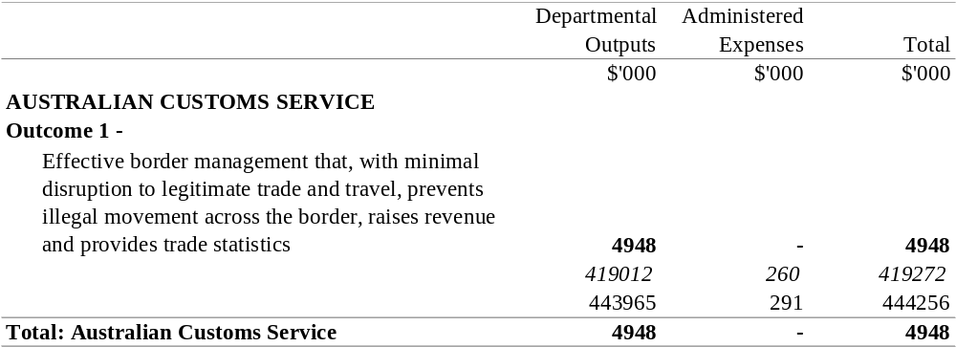

ATTORNEY-GENERAL’S PORTFOLIO
Additional Appropriation (bold figures) – 1999-2000
Budget Appropriation (italic figures) – 1999-2000
Estimated Expenses (light figures) – 1998-1999
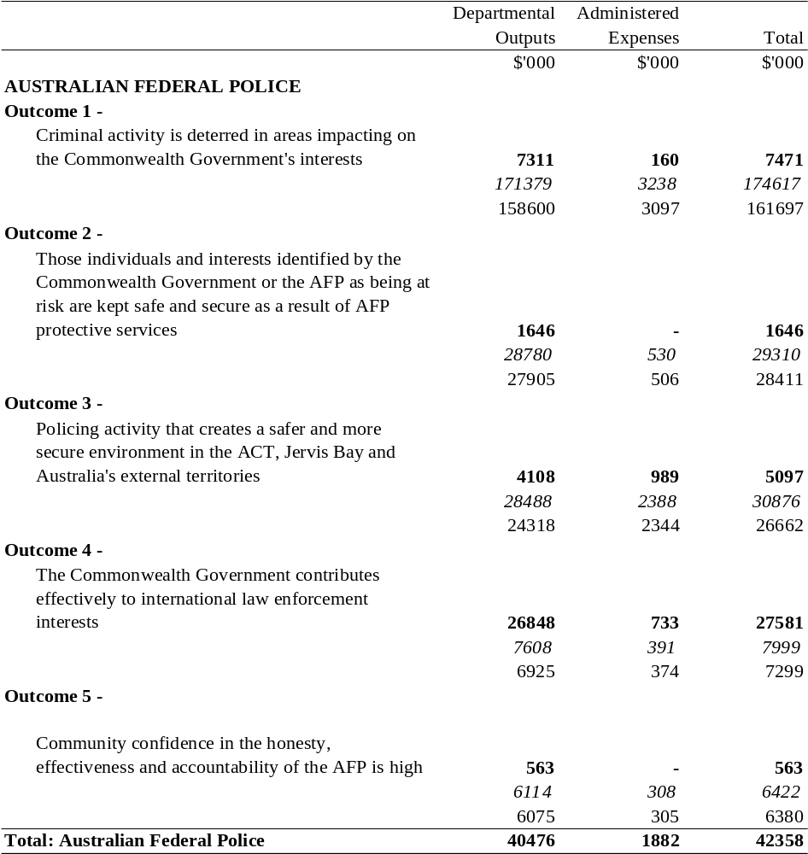

ATTORNEY-GENERAL’S PORTFOLIO
Additional Appropriation (bold figures) – 1999-2000
Budget Appropriation (italic figures) – 1999-2000
Estimated Expenses (light figures) – 1998-1999
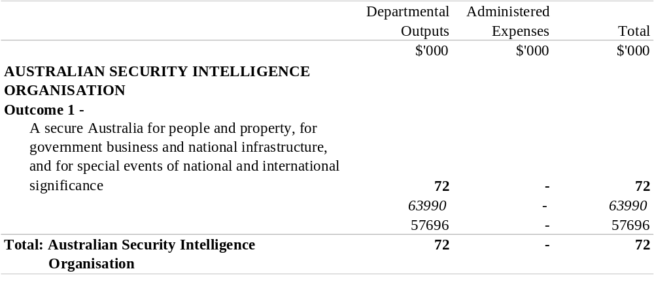

ATTORNEY-GENERAL’S PORTFOLIO
Additional Appropriation (bold figures) – 1999-2000
Budget Appropriation (italic figures) – 1999-2000
Estimated Expenses (light figures) – 1998-1999
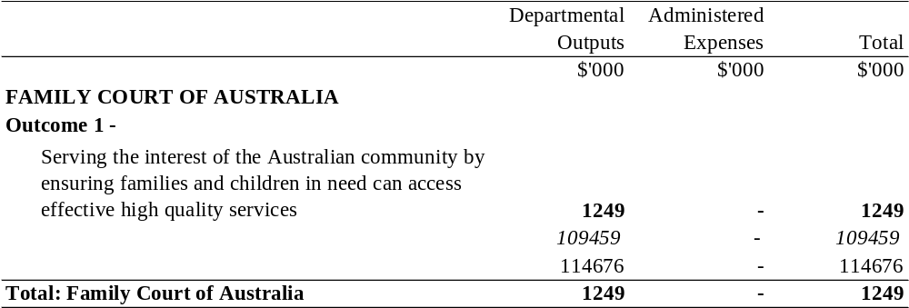

ATTORNEY-GENERAL’S PORTFOLIO
Additional Appropriation (bold figures) – 1999-2000
Budget Appropriation (italic figures) – 1999-2000
Estimated Expenses (light figures) – 1998-1999
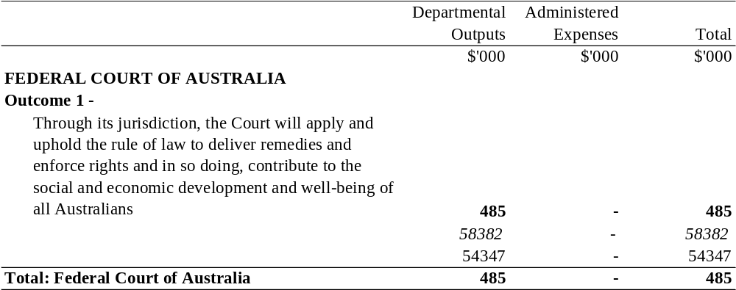

COMMUNICATIONS, INFORMATION TECHNOLOGY
AND THE ARTS PORTFOLIO

SUMMARY
Additional Appropriation (bold figures) – 1999-2000
Budget Appropriation (italic figures) – 1999-2000
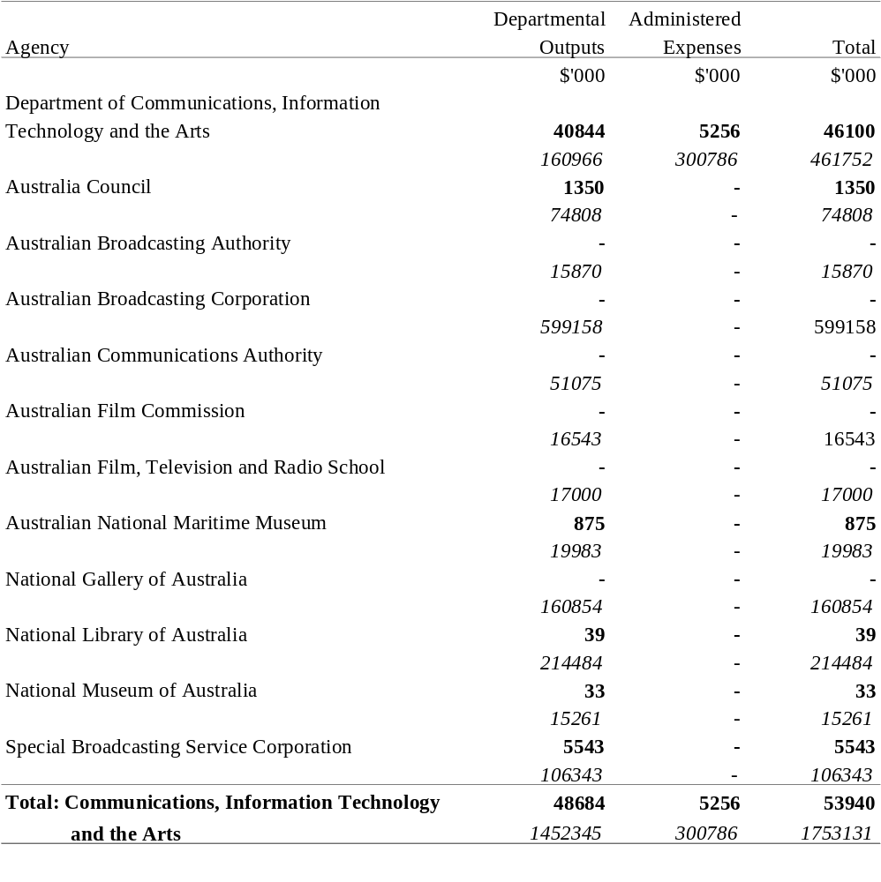

COMMUNICATIONS, INFORMATION TECHNOLOGY
AND THE ARTS PORTFOLIO
Additional Appropriation (bold figures) – 1999-2000
Budget Appropriation (italic figures) – 1999-2000
Estimated Expenses (light figures) – 1998-1999
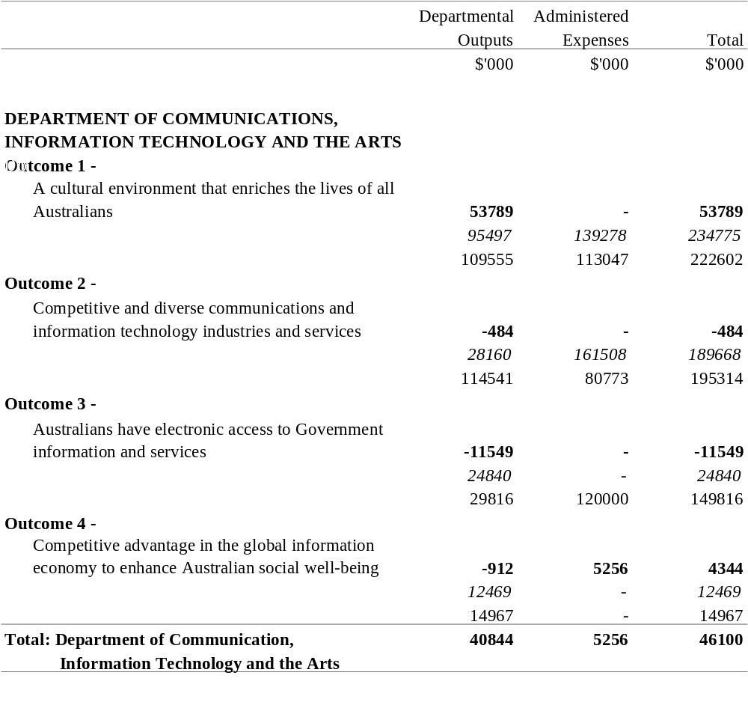

COMMUNICATIONS, INFORMATION TECHNOLOGY
AND THE ARTS PORTFOLIO
Additional Appropriation (bold figures) – 1999-2000
Budget Appropriation (italic figures) – 1999-2000
Estimated Expenses (light figures) – 1998-1999
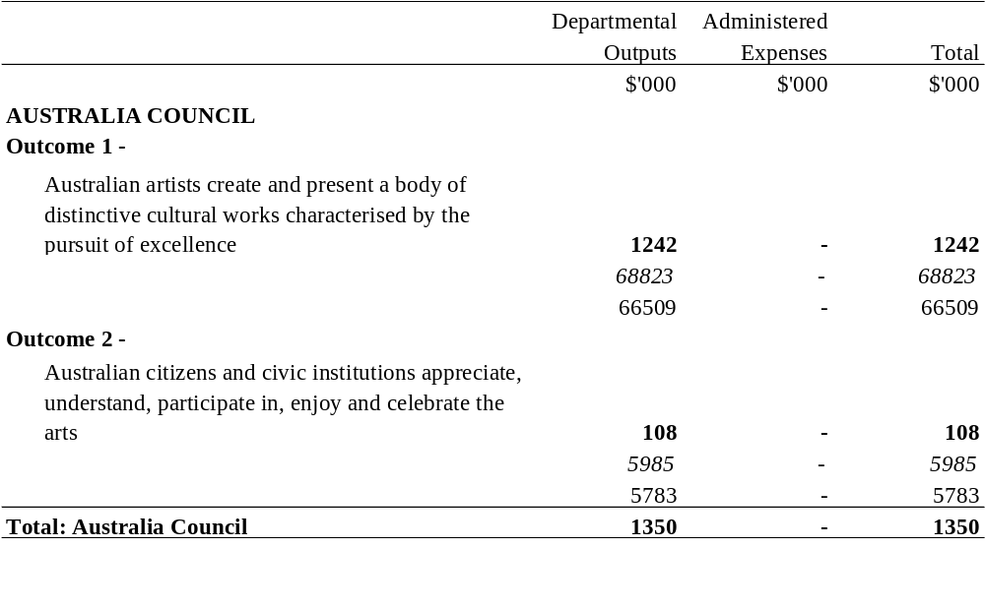

COMMUNICATIONS, INFORMATION TECHNOLOGY
AND THE ARTS PORTFOLIO
Additional Appropriation (bold figures) – 1999-2000
Budget Appropriation (italic figures) – 1999-2000
Estimated Expenses (light figures) – 1998-1999
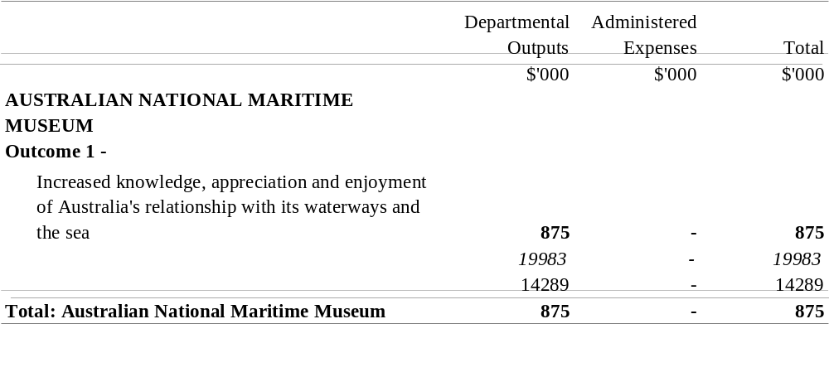

COMMUNICATIONS, INFORMATION TECHNOLOGY
AND THE ARTS PORTFOLIO
Additional Appropriation (bold figures) – 1999-2000
Budget Appropriation (italic figures) – 1999-2000
Estimated Expenses (light figures) – 1998-1999
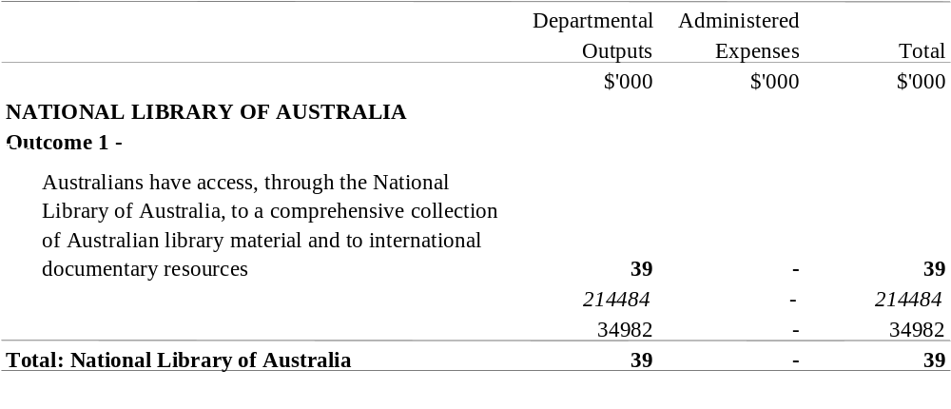

COMMUNICATIONS, INFORMATION TECHNOLOGY
AND THE ARTS PORTFOLIO
Additional Appropriation (bold figures) – 1999-2000
Budget Appropriation (italic figures) – 1999-2000
Estimated Expenses (light figures) – 1998-1999
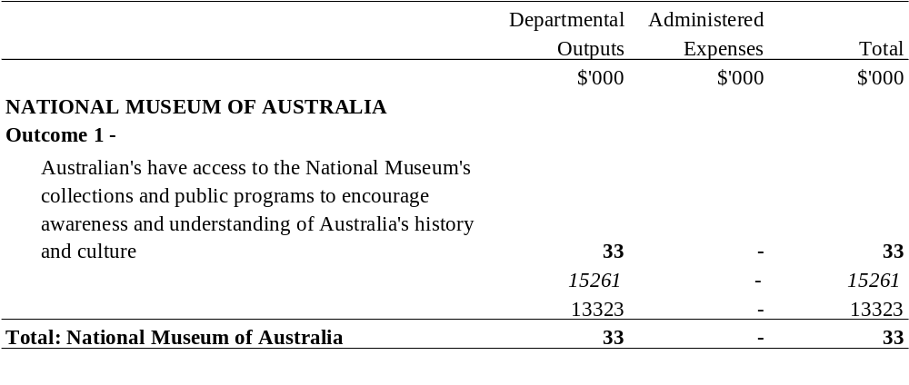

COMMUNICATIONS, INFORMATION TECHNOLOGY
AND THE ARTS PORTFOLIO
Additional Appropriation (bold figures) – 1999-2000
Budget Appropriation (italic figures) – 1999-2000
Estimated Expenses (light figures) – 1998-1999
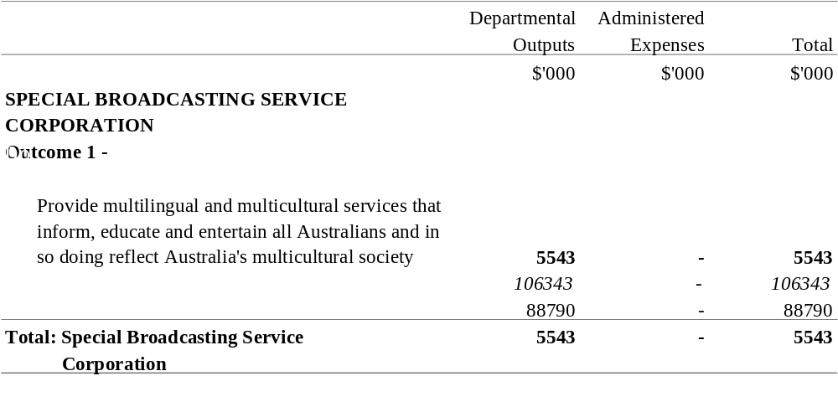

DEFENCE PORTFOLIO

SUMMARY
Additional Appropriation (bold figures) – 1999-2000
Budget Appropriation (italic figures) – 1999-2000
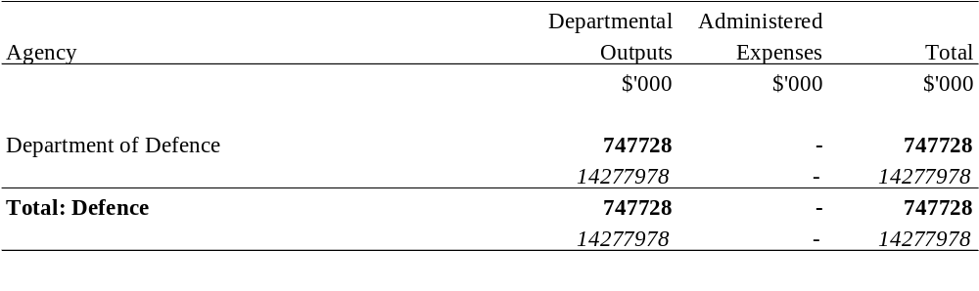

DEFENCE PORTFOLIO
Additional Appropriation (bold figures) – 1999-2000
Budget Appropriation (italic figures) – 1999-2000
Estimated Expenses (light figures) – 1998-1999
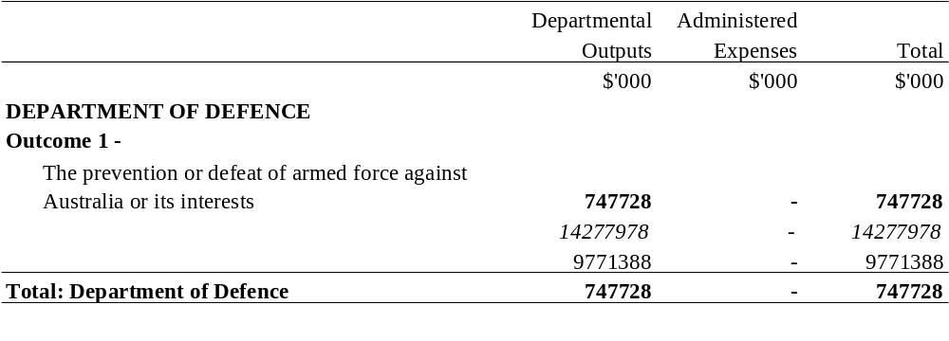

VETERANS’ AFFAIRS PORTFOLIO

SUMMARY
Additional Appropriation (bold figures) – 1999-2000
Budget Appropriation (italic figures) – 1999-2000
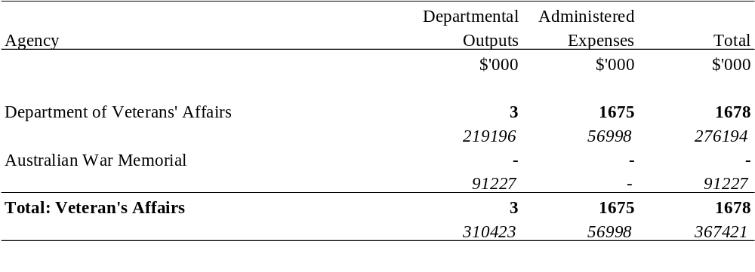

VETERANS’ AFFAIRS PORTFOLIO
Additional Appropriation (bold figures) – 1999-2000
Budget Appropriation (italic figures) – 1999-2000
Estimated Expenses (light figures) – 1998-1999
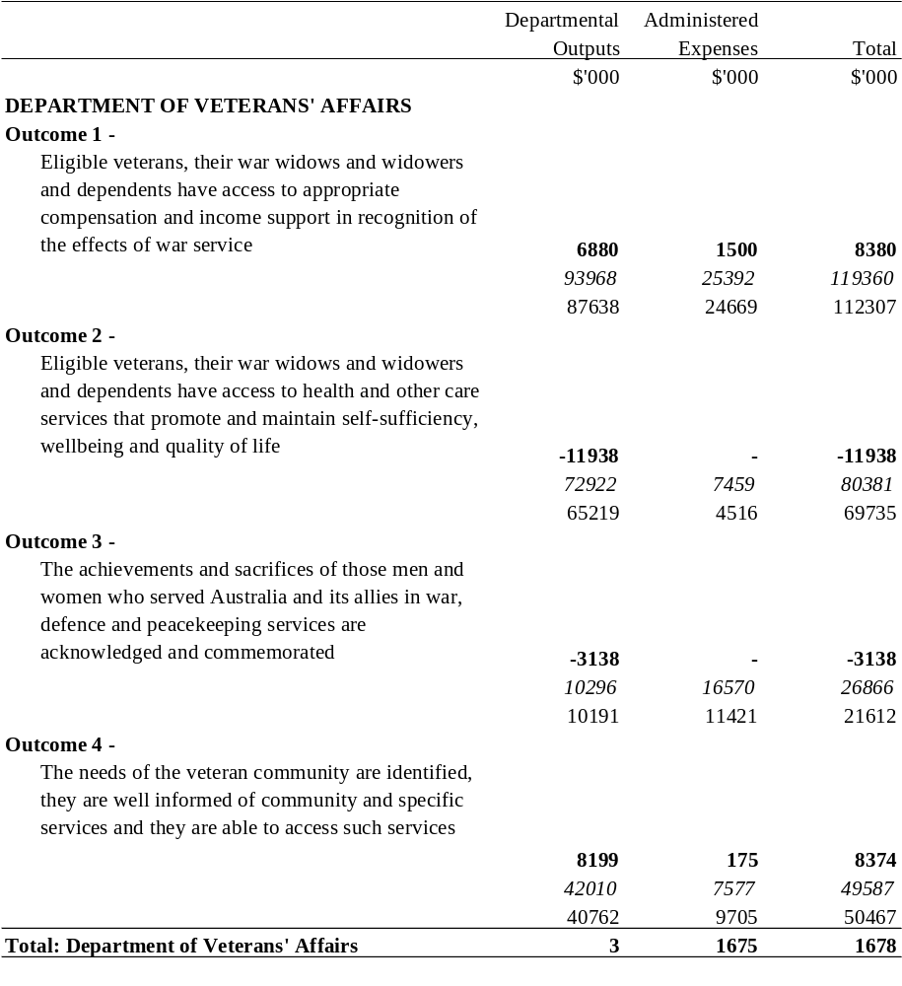

EDUCATION, TRAINING AND YOUTH AFFAIRS PORTFOLIO

SUMMARY
Additional Appropriation (bold figures) – 1999-2000
Budget Appropriation (italic figures) – 1999-2000
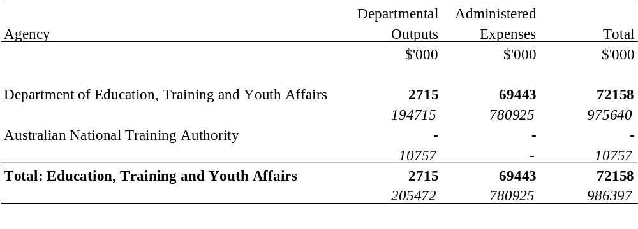

EDUCATION, TRAINING AND YOUTH AFFAIRS PORTFOLIO
Additional Appropriation (bold figures) – 1999-2000
Budget Appropriation (italic figures) – 1999-2000
Estimated Expenses (light figures) – 1998-1999
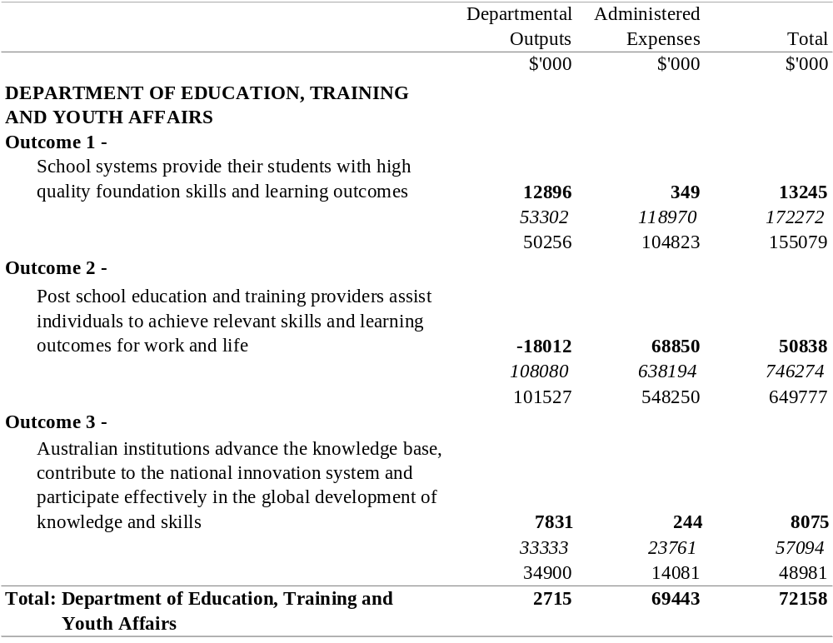

EMPLOYMENT, WORKPLACE RELATIONS
AND SMALL BUSINESS PORTFOLIO

SUMMARY
Additional Appropriation (bold figures) – 1999-2000
Budget Appropriation (italic figures) – 1999-2000
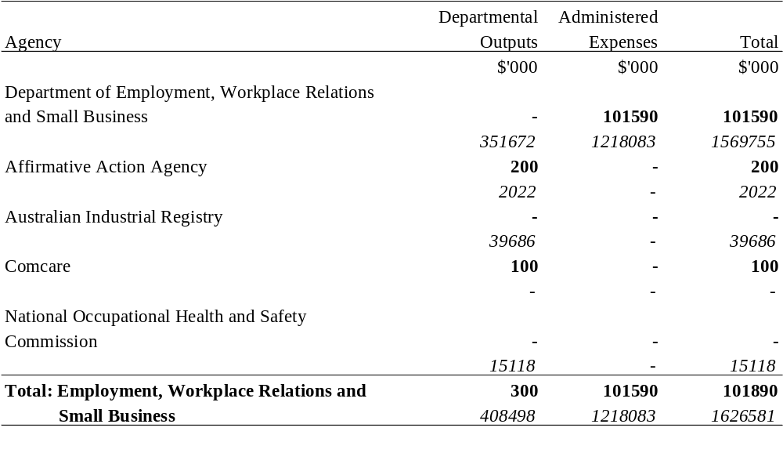

EMPLOYMENT, WORKPLACE RELATIONS
AND SMALL BUSINESS PORTFOLIO
Additional Appropriation (bold figures) – 1999-2000
Budget Appropriation (italic figures) – 1999-2000
Estimated Expenses (light figures) – 1998-1999
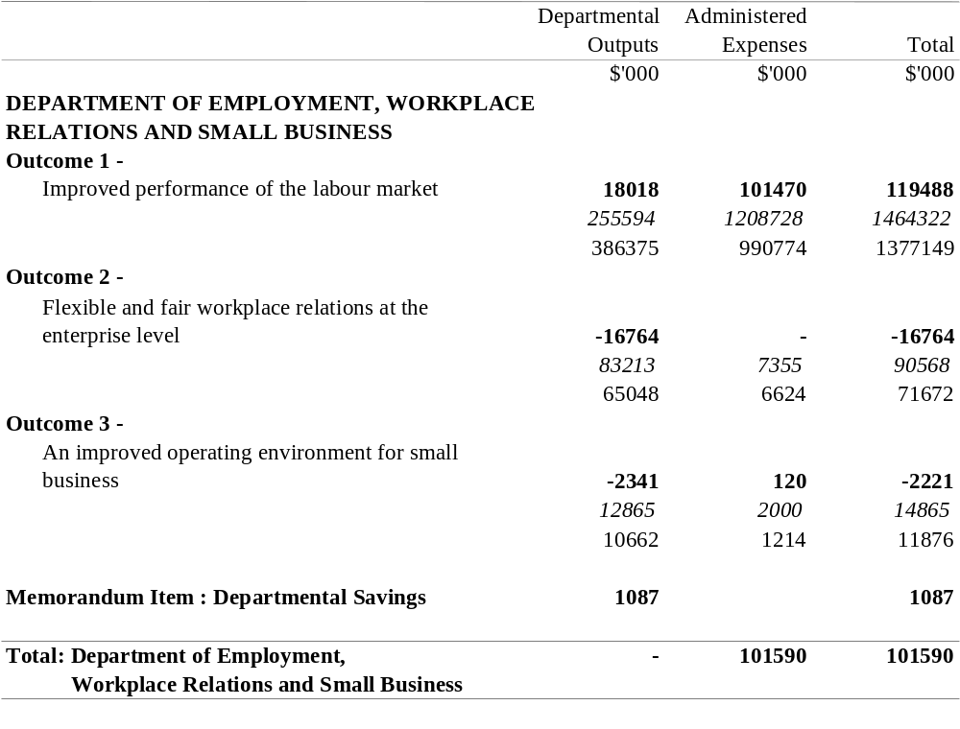
The Memorandum Item represents savings in departmental expenses consistent with the Statement of Savings document. Note that the amounts set out opposite outcomes, under the heading "Departmental Outputs", are notional. They do not form part of the total departmental appropriation item and do not in any way restrict the scope of the expenditure authorised by the item.

EMPLOYMENT, WORKPLACE RELATIONS
AND SMALL BUSINESS PORTFOLIO
Additional Appropriation (bold figures) – 1999-2000
Budget Appropriation (italic figures) – 1999-2000
Estimated Expenses (light figures) – 1998-1999
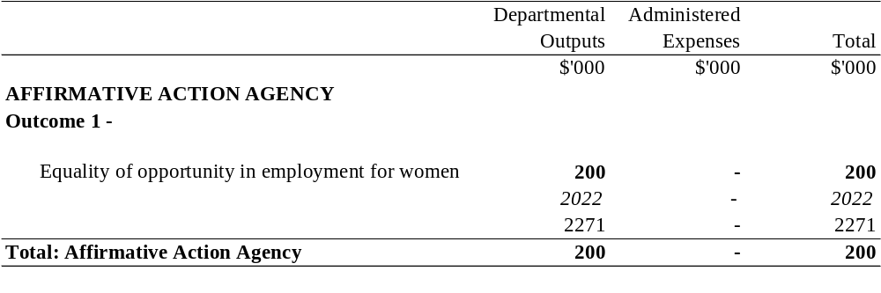

EMPLOYMENT, WORKPLACE RELATIONS
AND SMALL BUSINESS PORTFOLIO
Additional Appropriation (bold figures) – 1999-2000
Budget Appropriation (italic figures) – 1999-2000
Estimated Expenses (light figures) – 1998-1999
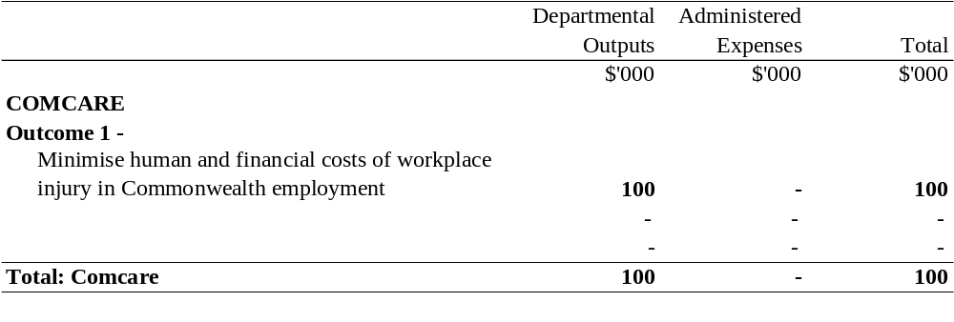
ENVIRONMENT AND HERITAGE PORTFOLIO

SUMMARY
Additional Appropriation (bold figures) – 1999-2000
Budget Appropriation (italic figures) – 1999-2000
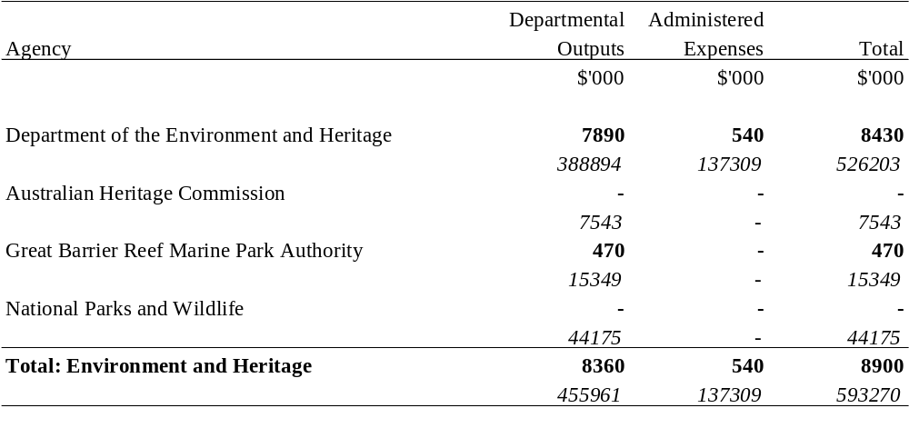

ENVIRONMENT AND HERITAGE PORTFOLIO
Additional Appropriation (bold figures) – 1999-2000
Budget Appropriation (italic figures) – 1999-2000
Estimated Expenses (light figures) – 1998-1999
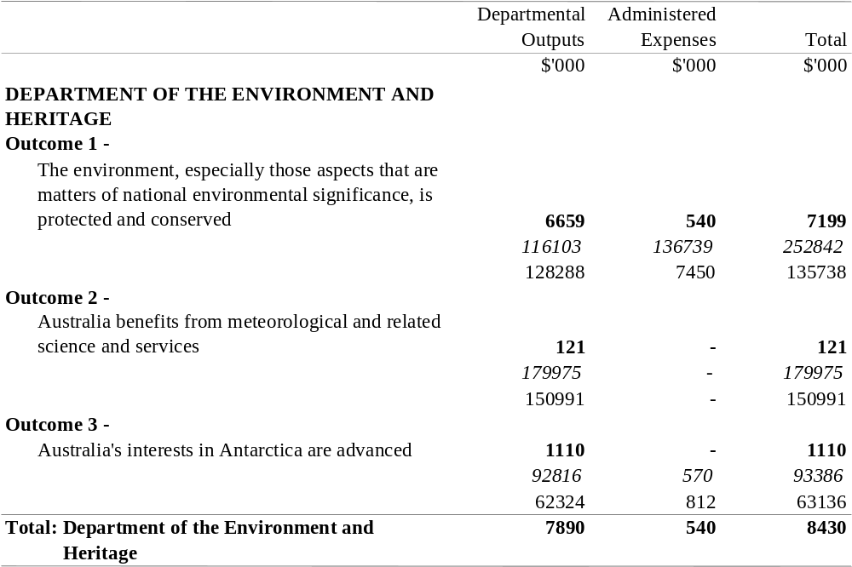

ENVIRONMENT AND HERITAGE PORTFOLIO
Additional Appropriation (bold figures) – 1999-2000
Budget Appropriation (italic figures) – 1999-2000
Estimated Expenses (light figures) – 1998-1999
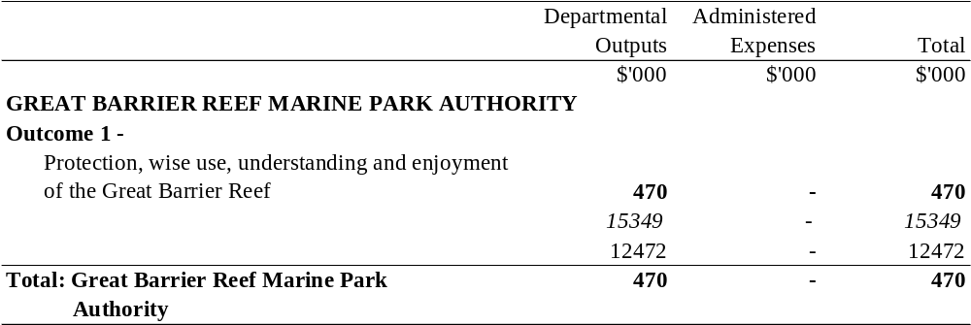

FAMILY AND COMMUNITY SERVICES PORTFOLIO

SUMMARY
Additional Appropriation (bold figures) – 1999-2000
Budget Appropriation (italic figures) – 1999-2000
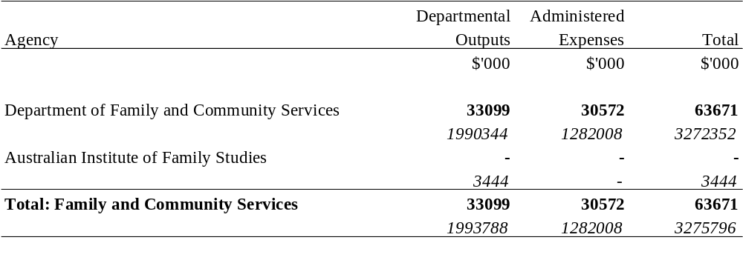

FAMILY AND COMMUNITY SERVICES PORTFOLIO
Additional Appropriation (bold figures) – 1999-2000
Budget Appropriation (italic figures) – 1999-2000
Estimated Expenses (light figures) – 1998-1999
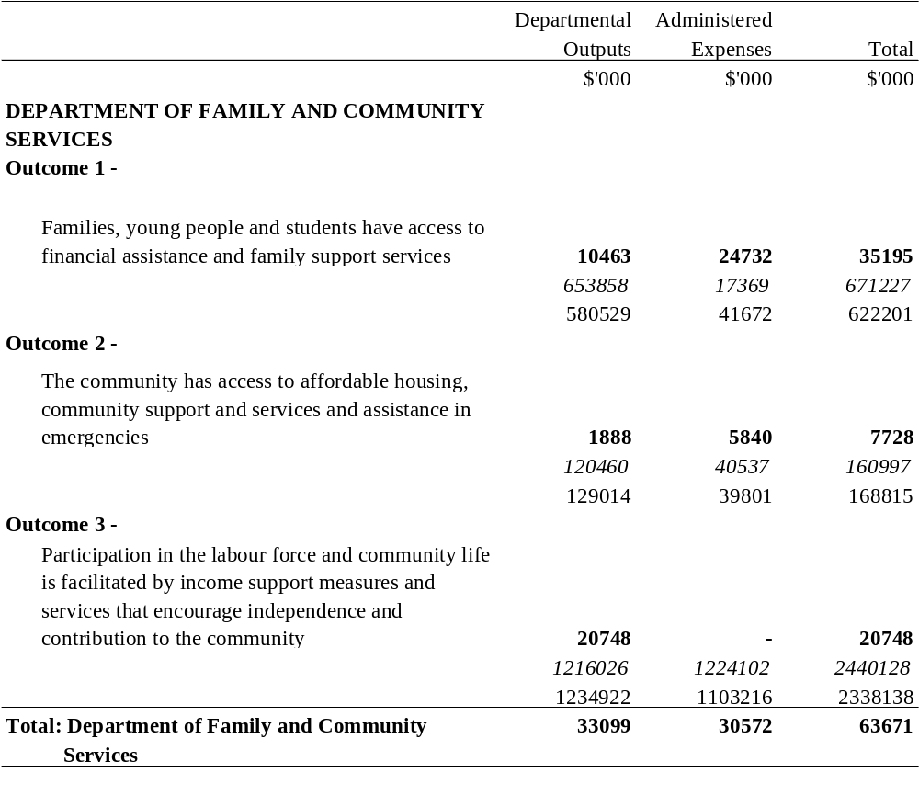

FINANCE AND ADMINISTRATION

SUMMARY
Additional Appropriation (bold figures) – 1999-2000
Budget Appropriation (italic figures) – 1999-2000
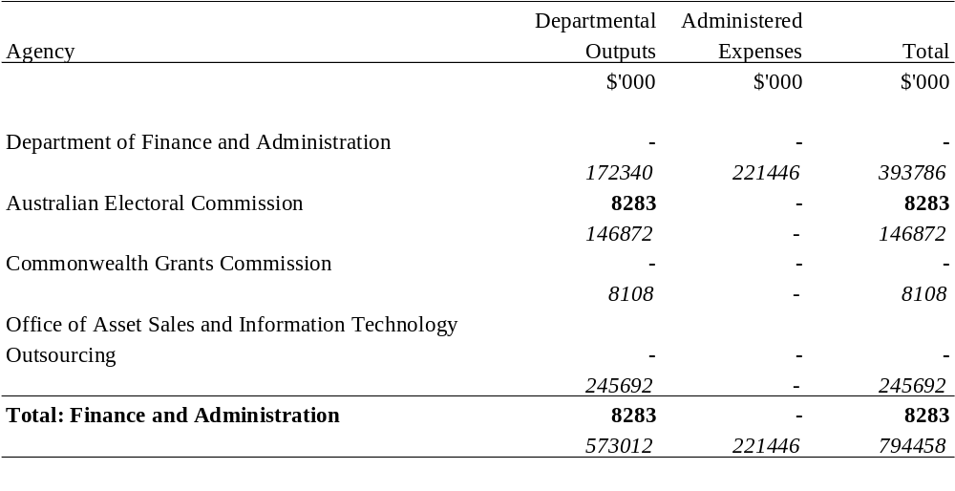

FINANCE AND ADMINISTRATION
Additional Appropriation (bold figures) – 1999-2000
Budget Appropriation (italic figures) – 1999-2000
Estimated Expenses (light figures) – 1998-1999
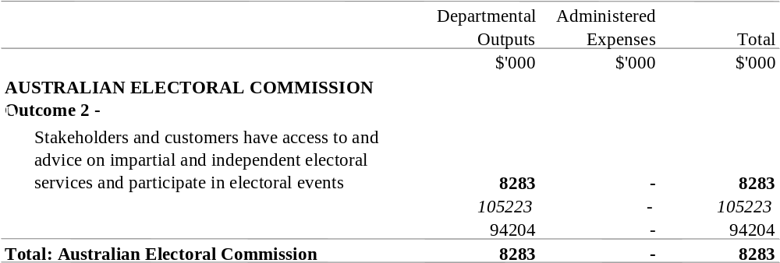

FOREIGN AFFAIRS AND TRADE PORTFOLIO

SUMMARY
Additional Appropriation (bold figures) – 1999-2000
Budget Appropriation (italic figures) – 1999-2000
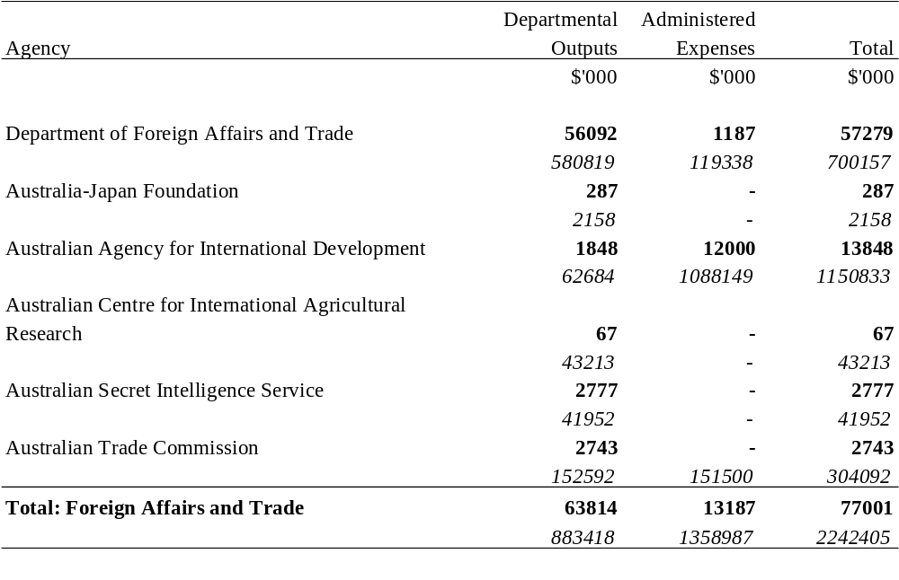

FOREIGN AFFAIRS AND TRADE PORTFOLIO
Additional Appropriation (bold figures) – 1999-2000
Budget Appropriation (italic figures) – 1999-2000
Estimated Expenses (light figures) – 1998-1999
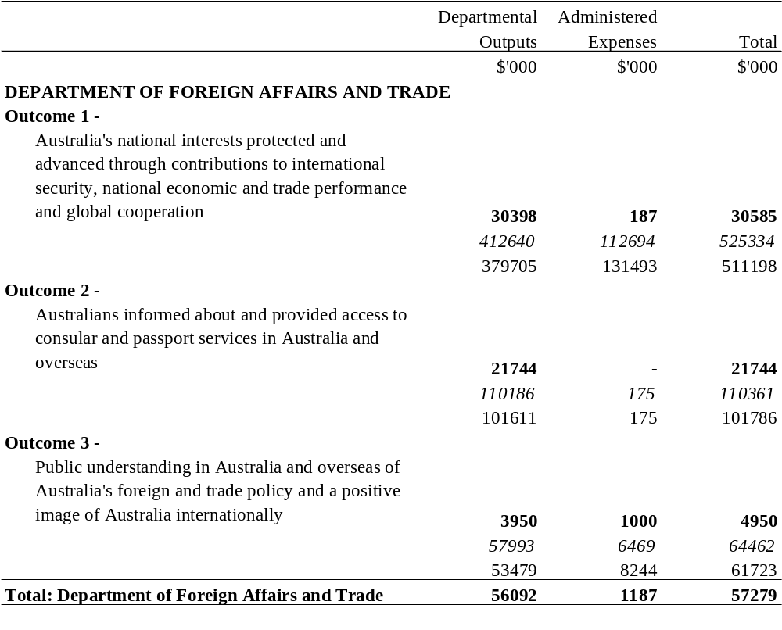

FOREIGN AFFAIRS AND TRADE PORTFOLIO
Additional Appropriation (bold figures) – 1999-2000
Budget Appropriation (italic figures) – 1999-2000
Estimated Expenses (light figures) – 1998-1999
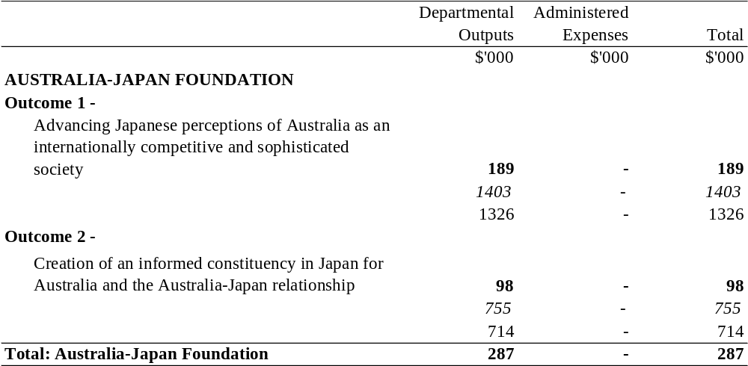

FOREIGN AFFAIRS AND TRADE PORTFOLIO
Additional Appropriation (bold figures) – 1999-2000
Budget Appropriation (italic figures) – 1999-2000
Estimated Expenses (light figures) – 1998-1999
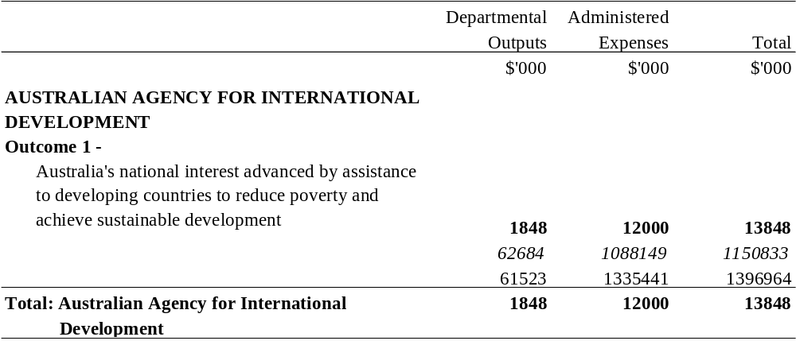

FOREIGN AFFAIRS AND TRADE PORTFOLIO
Additional Appropriation (bold figures) – 1999-2000
Budget Appropriation (italic figures) – 1999-2000
Estimated Expenses (light figures) – 1998-1999
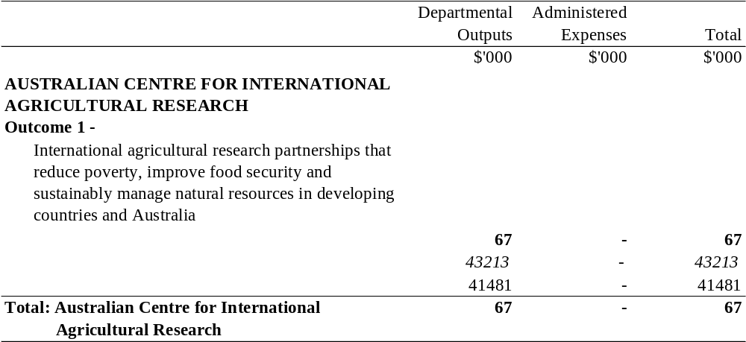

FOREIGN AFFAIRS AND TRADE PORTFOLIO
Additional Appropriation (bold figures) – 1999-2000
Budget Appropriation (italic figures) – 1999-2000
Estimated Expenses (light figures) – 1998-1999
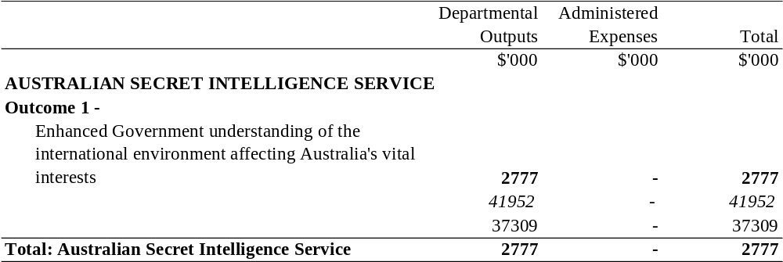

FOREIGN AFFAIRS AND TRADE PORTFOLIO
Additional Appropriation (bold figures) – 1999-2000
Budget Appropriation (italic figures) – 1999-2000
Estimated Expenses (light figures) – 1998-1999
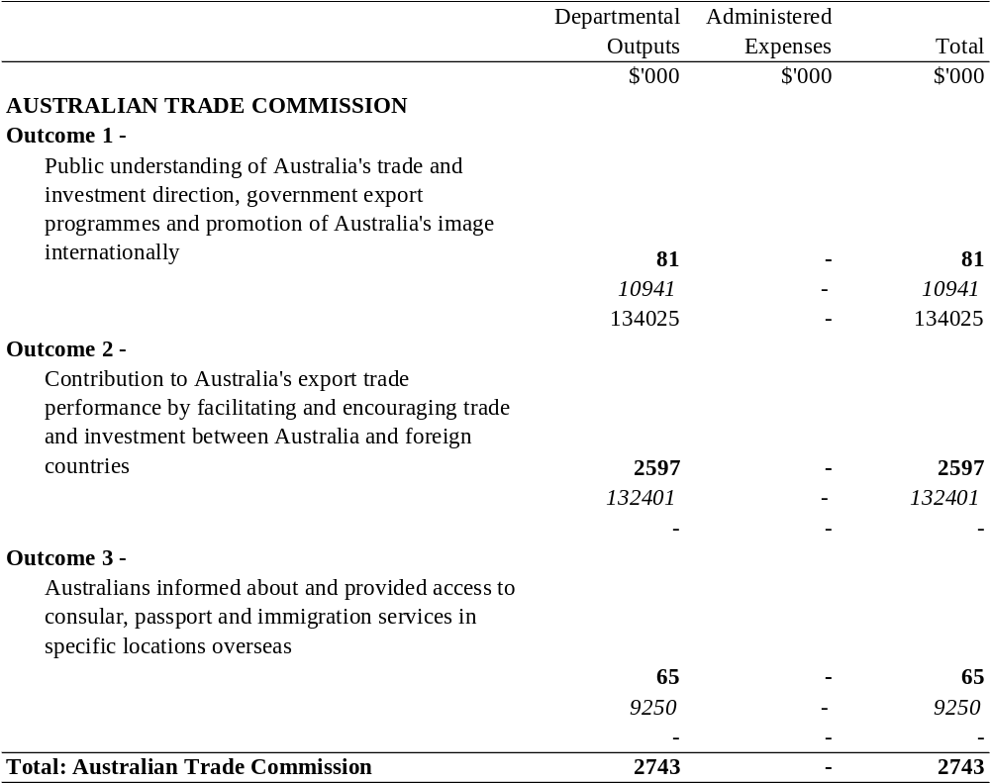

HEALTH AND AGED CARE PORTFOLIO

SUMMARY
Additional Appropriation (bold figures) – 1999-2000
Budget Appropriation (italic figures) – 1999-2000
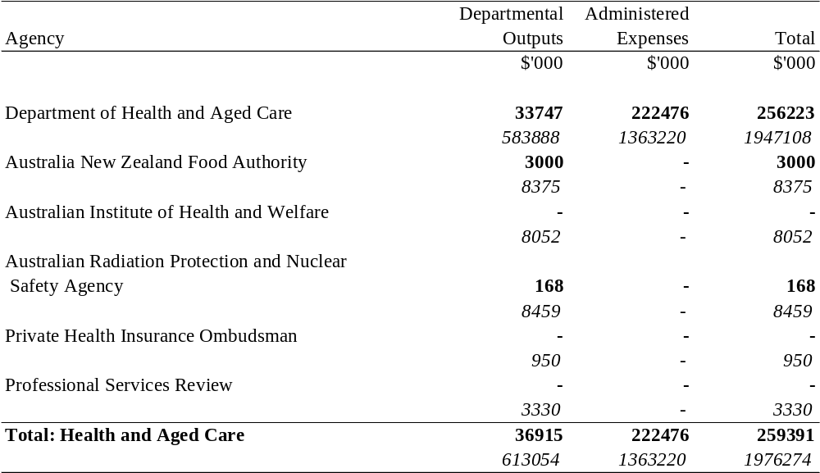

HEALTH AND AGED CARE PORTFOLIO
Additional Appropriation (bold figures) – 1999-2000
Budget Appropriation (italic figures) – 1999-2000
Estimated Expenses (light figures) – 1998-1999
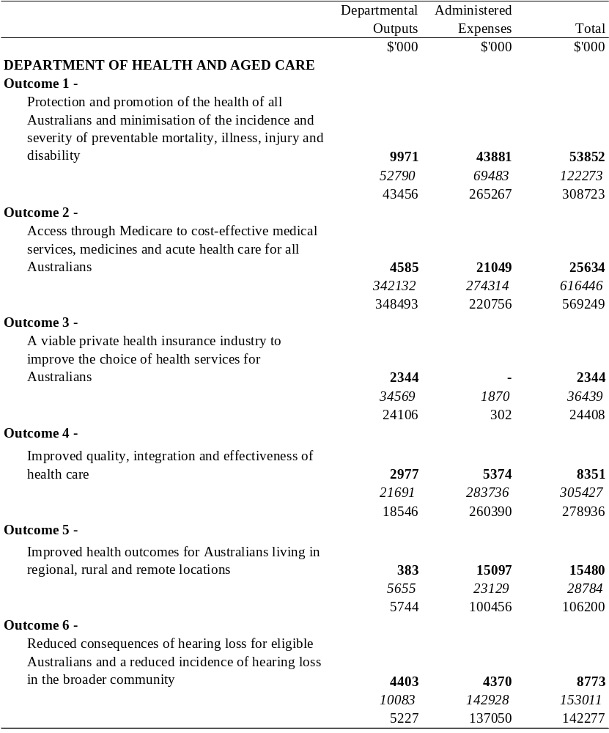

HEALTH AND AGED CARE PORTFOLIO
Additional Appropriation (bold figures) – 1999-2000
Budget Appropriation (italic figures) – 1999-2000
Estimated Expenses (light figures) – 1998-1999
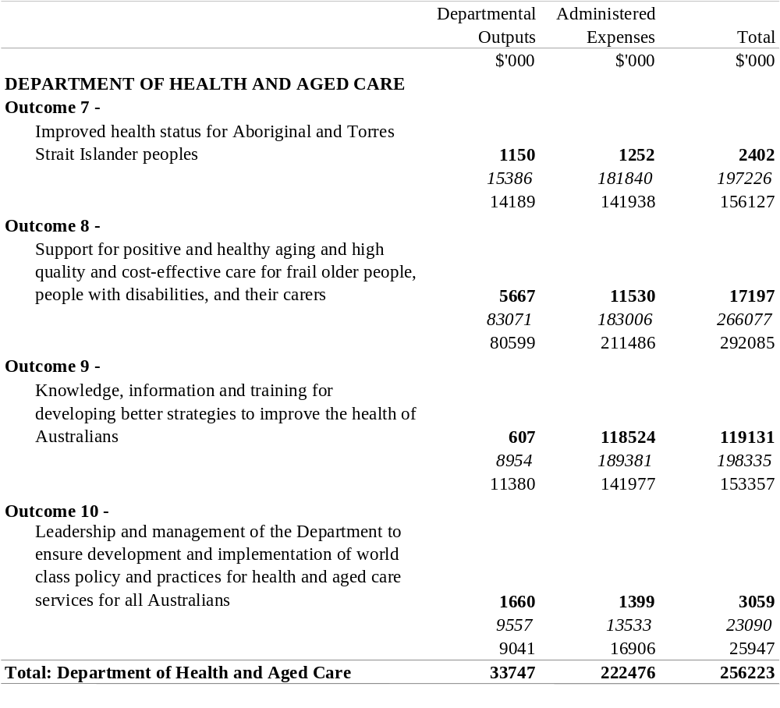

HEALTH AND AGED CARE PORTFOLIO
Additional Appropriation (bold figures) – 1999-2000
Budget Appropriation (italic figures) – 1999-2000
Estimated Expenses (light figures) – 1998-1999
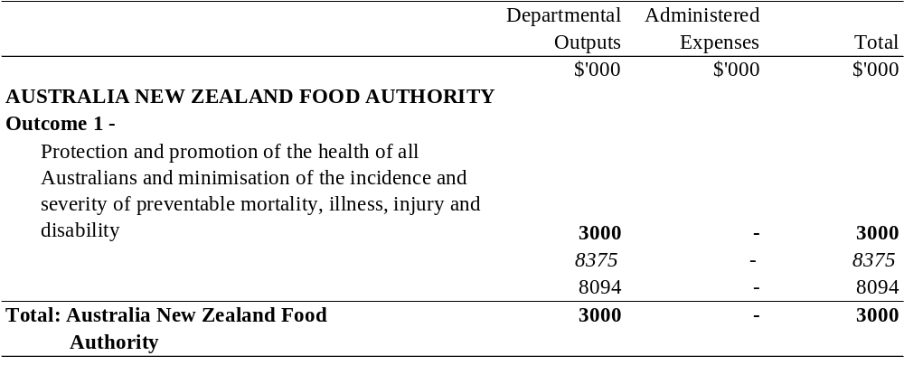

HEALTH AND AGED CARE PORTFOLIO
Additional Appropriation (bold figures) – 1999-2000
Budget Appropriation (italic figures) – 1999-2000
Estimated Expenses (light figures) – 1998-1999
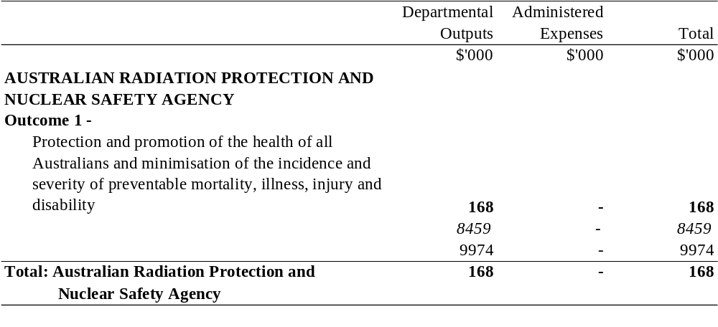

IMMIGRATION AND MULTICULTURAL AFFAIRS PORTFOLIO

SUMMARY
Additional Appropriation (bold figures) – 1999-2000
Budget Appropriation (italic figures) – 1999-2000
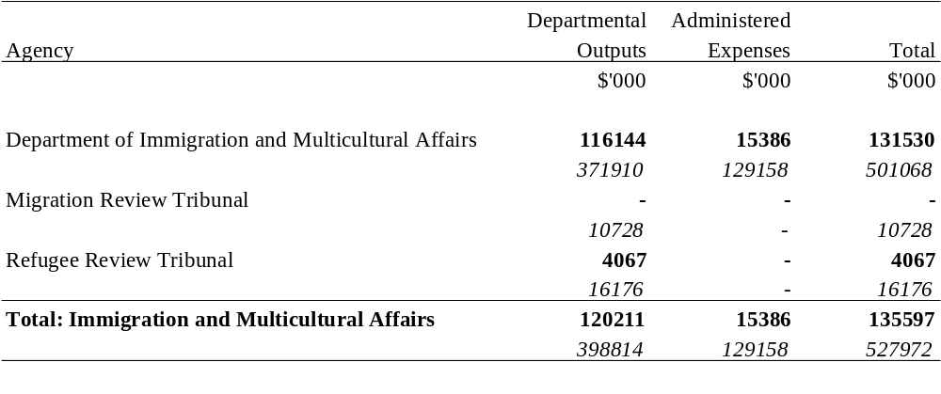

IMMIGRATION AND MULTICULTURAL AFFAIRS PORTFOLIO
Additional Appropriation (bold figures) – 1999-2000
Budget Appropriation (italic figures) – 1999-2000
Estimated Expenses (light figures) – 1998-1999
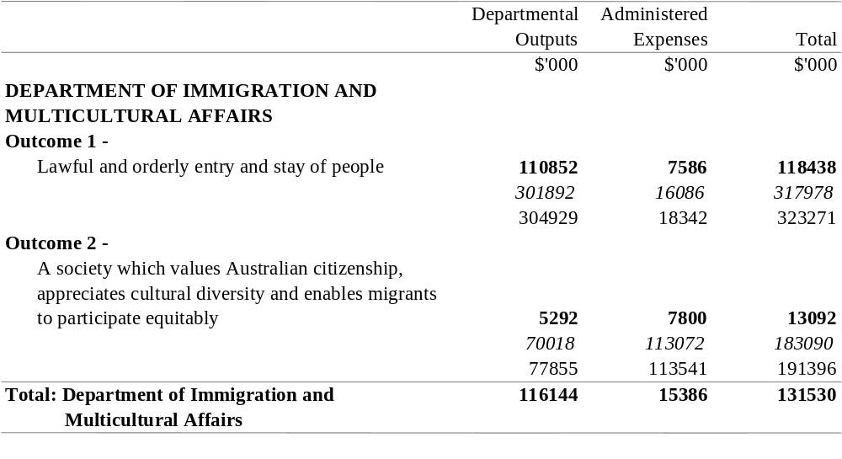

IMMIGRATION AND MULTICULTURAL AFFAIRS PORTFOLIO
Additional Appropriation (bold figures) – 1999-2000
Budget Appropriation (italic figures) – 1999-2000
Estimated Expenses (light figures) – 1998-1999
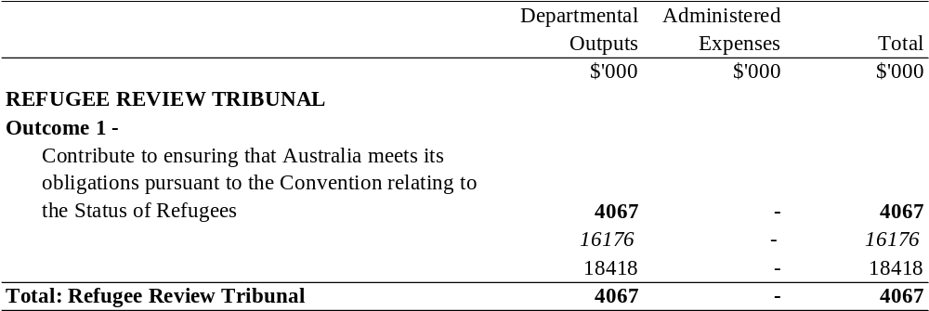

INDUSTRY, SCIENCE AND RESOURCES PORTFOLIO

SUMMARY
Additional Appropriation (bold figures) – 1999-2000
Budget Appropriation (italic figures) – 1999-2000
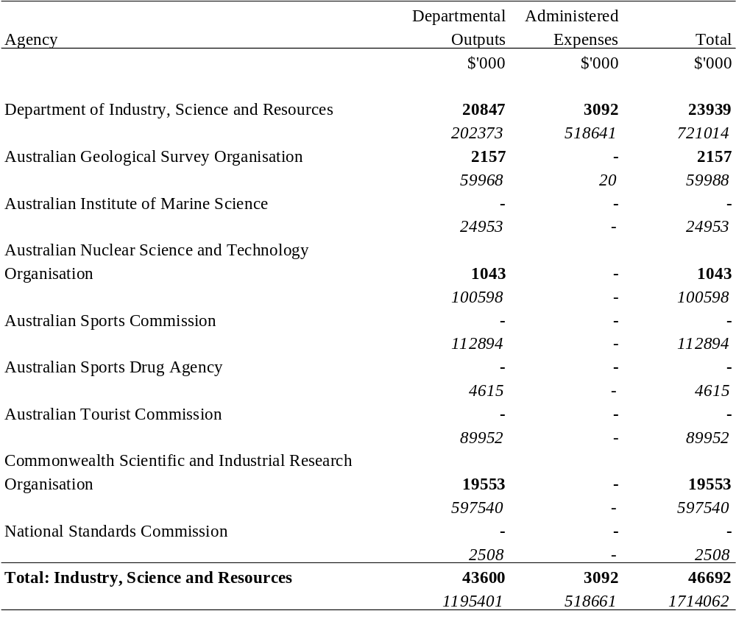

INDUSTRY, SCIENCE AND RESOURCES PORTFOLIO
Additional Appropriation (bold figures) – 1999-2000
Budget Appropriation (italic figures) – 1999-2000
Estimated Expenses (light figures) – 1998-1999
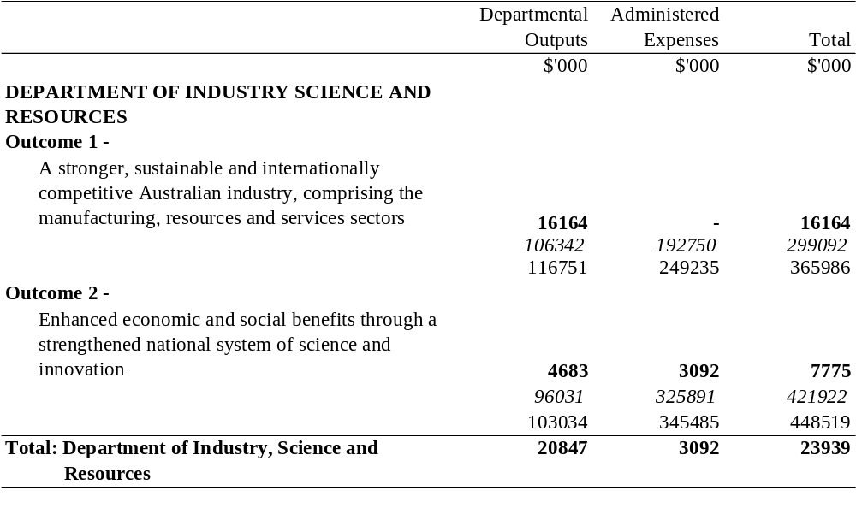

INDUSTRY, SCIENCE AND RESOURCES PORTFOLIO
Additional Appropriation (bold figures) – 1999-2000
Budget Appropriation (italic figures) – 1999-2000
Estimated Expenses (light figures) – 1998-1999
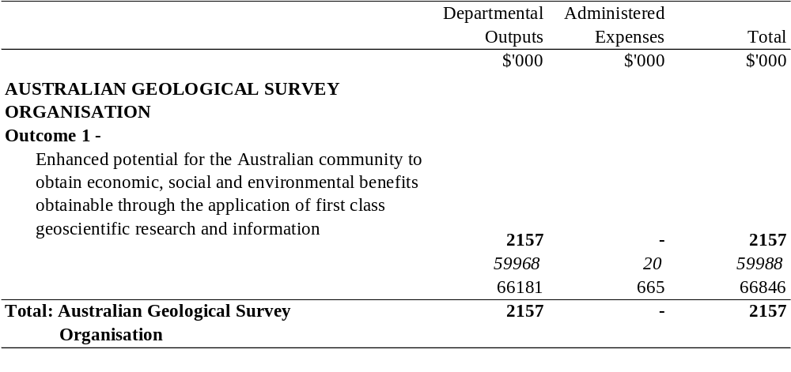

INDUSTRY, SCIENCE AND RESOURCES PORTFOLIO
Additional Appropriation (bold figures) – 1999-2000
Budget Appropriation (italic figures) – 1999-2000
Estimated Expenses (light figures) – 1998-1999
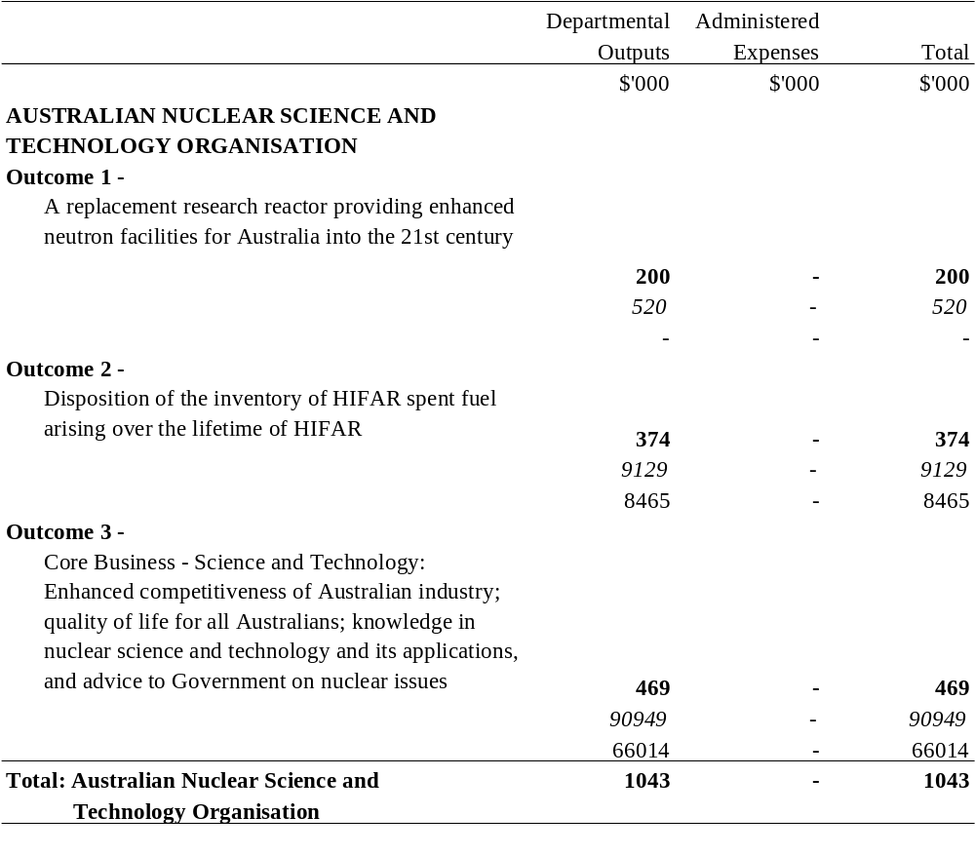

INDUSTRY, SCIENCE AND RESOURCES PORTFOLIO
Additional Appropriation (bold figures) – 1999-2000
Budget Appropriation (italic figures) – 1999-2000
Estimated Expenses (light figures) – 1998-1999
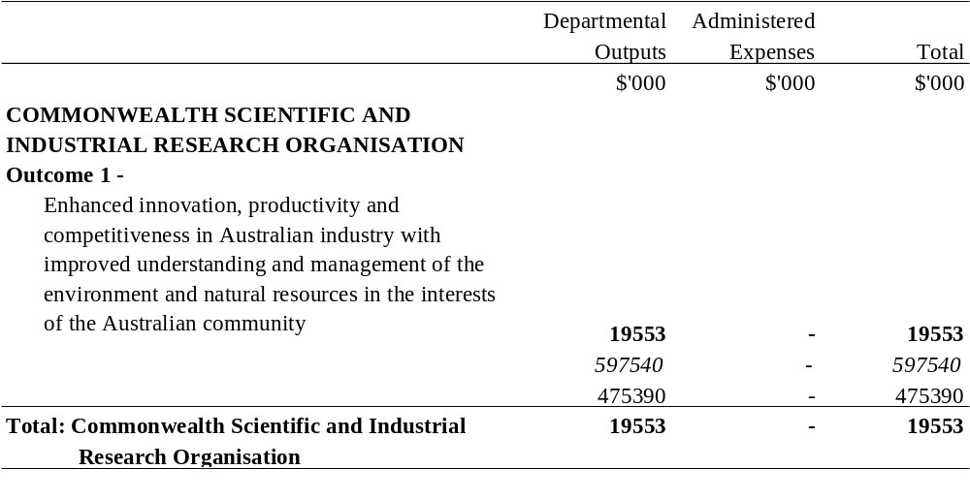

PRIME MINISTER AND CABINET PORTFOLIO

SUMMARY
Additional Appropriation (bold figures) – 1999-2000
Budget Appropriation (italic figures) – 1999-2000
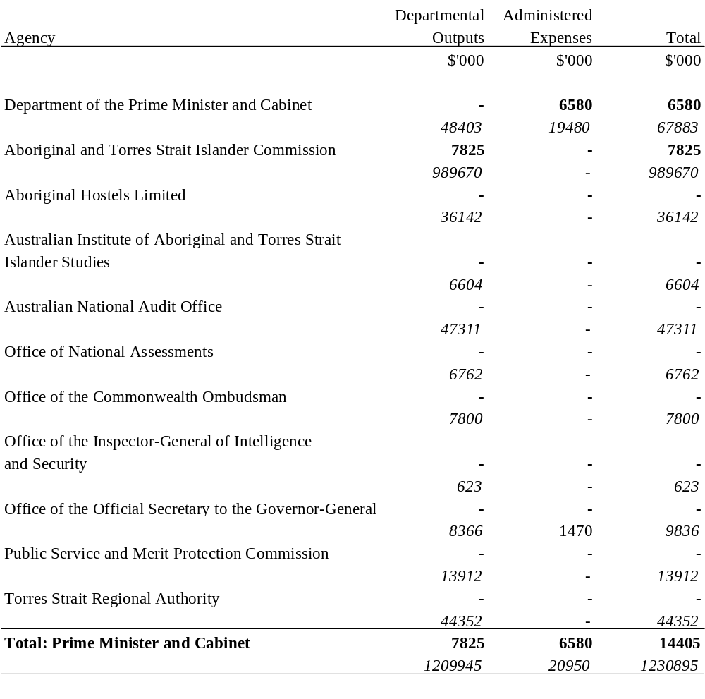

PRIME MINISTER AND CABINET PORTFOLIO
Additional Appropriation (bold figures) – 1999-2000
Budget Appropriation (italic figures) – 1999-2000
Estimated Expenses (light figures) – 1998-1999
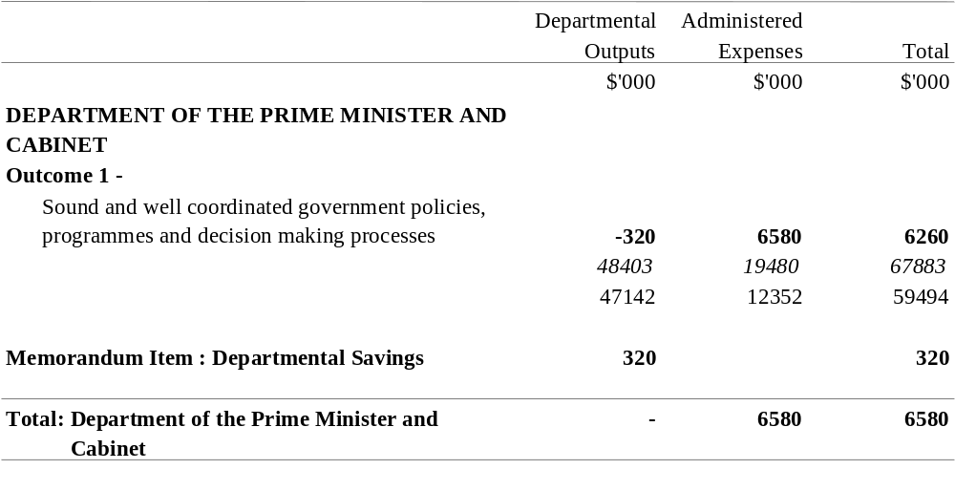
The Memorandum Item represents savings in departmental expenses consistent with the Statement of Savings document. Note that the amounts set out opposite outcomes, under the heading "Departmental Outputs", are notional. They do not form part of the total departmental appropriation item and do not in any way restrict the scope of the expenditure authorised by the item.

PRIME MINISTER AND CABINET PORTFOLIO
Additional Appropriation (bold figures) – 1999-2000
Budget Appropriation (italic figures) – 1999-2000
Estimated Expenses (light figures) – 1998-1999
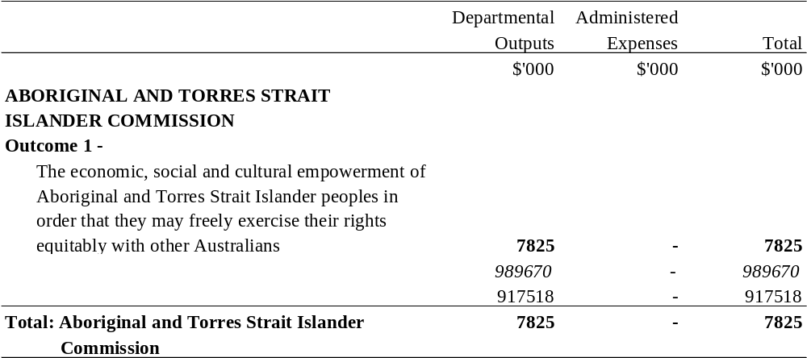

TRANSPORT AND REGIONAL SERVICES PORTFOLIO

SUMMARY
Additional Appropriation (bold figures) – 1999-2000
Budget Appropriation (italic figures) – 1999-2000
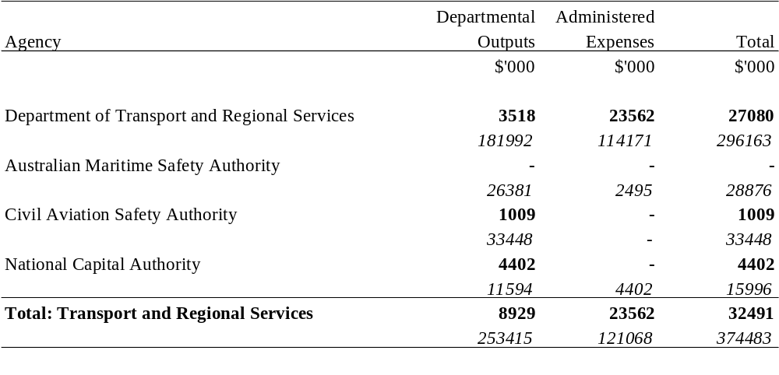

TRANSPORT AND REGIONAL SERVICES PORTFOLIO
Additional Appropriation (bold figures) – 1999-2000
Budget Appropriation (italic figures) – 1999-2000
Estimated Expenses (light figures) – 1998-1999
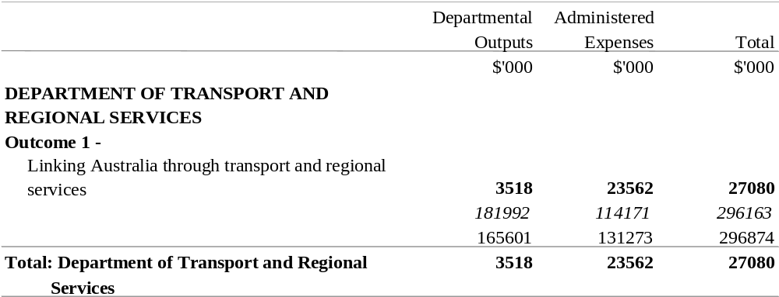

TRANSPORT AND REGIONAL SERVICES PORTFOLIO
Additional Appropriation (bold figures) – 1999-2000
Budget Appropriation (italic figures) – 1999-2000
Estimated Expenses (light figures) – 1998-1999
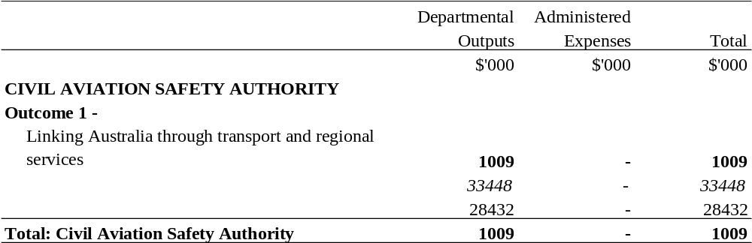

TRANSPORT AND REGIONAL SERVICES PORTFOLIO
Additional Appropriation (bold figures) – 1999-2000
Budget Appropriation (italic figures) – 1999-2000
Estimated Expenses (light figures) – 1998-1999
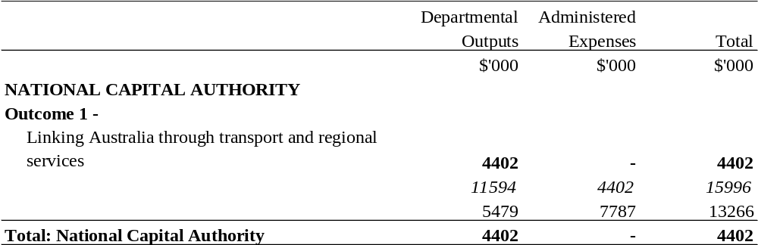

TREASURY PORTFOLIO

SUMMARY
Additional Appropriation (bold figures) – 1999-2000
Budget Appropriation (italic figures) – 1999-2000
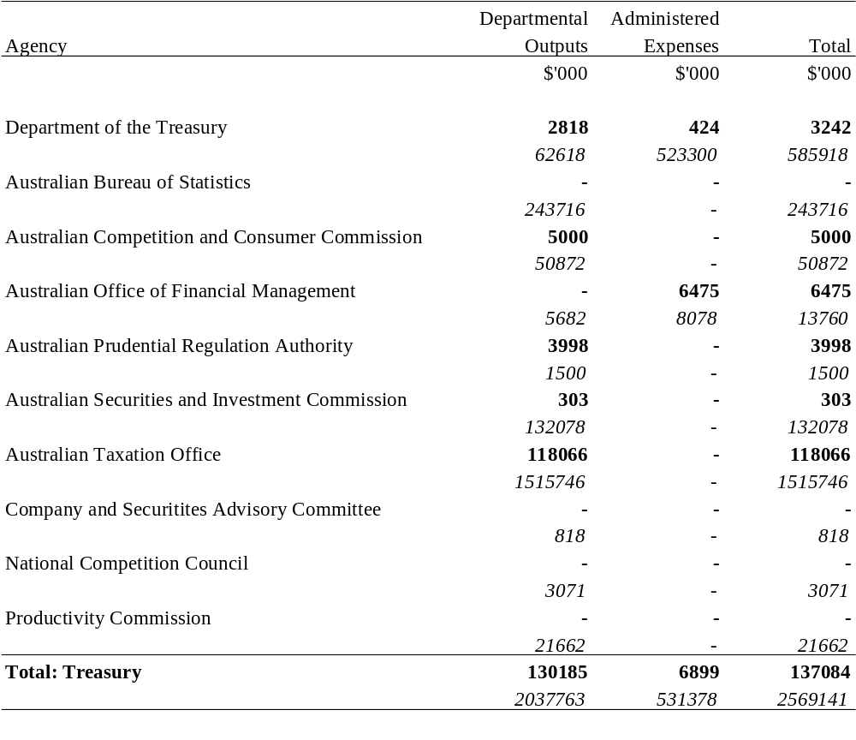

TREASURY PORTFOLIO
Additional Appropriation (bold figures) – 1999-2000
Budget Appropriation (italic figures) – 1999-2000
Estimated Expenses (light figures) – 1998-1999
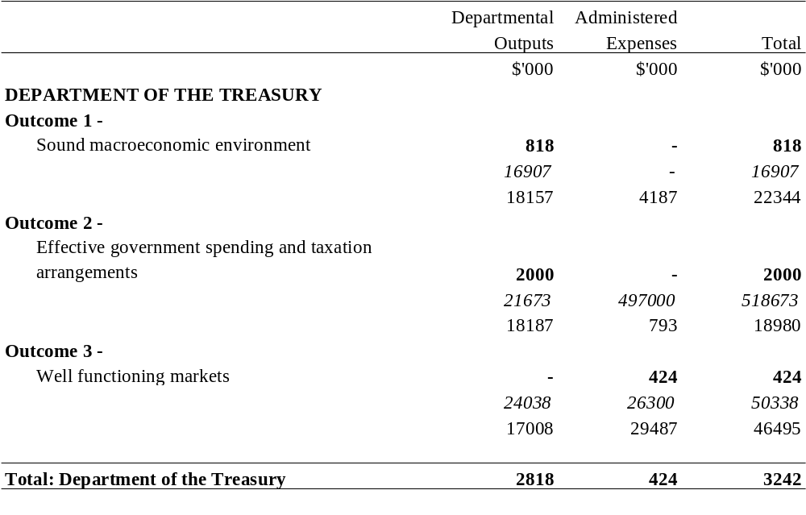

TREASURY PORTFOLIO
Additional Appropriation (bold figures) – 1999-2000
Budget Appropriation (italic figures) – 1999-2000
Estimated Expenses (light figures) – 1998-1999

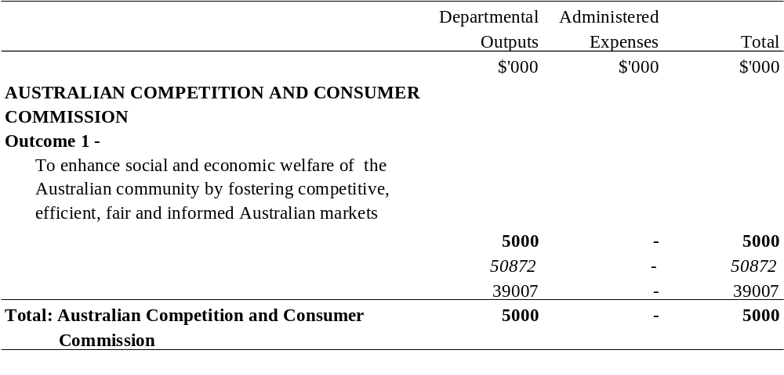

TREASURY PORTFOLIO
Additional Appropriation (bold figures) – 1999-2000
Budget Appropriation (italic figures) – 1999-2000
Estimated Expenses (light figures) – 1998-1999
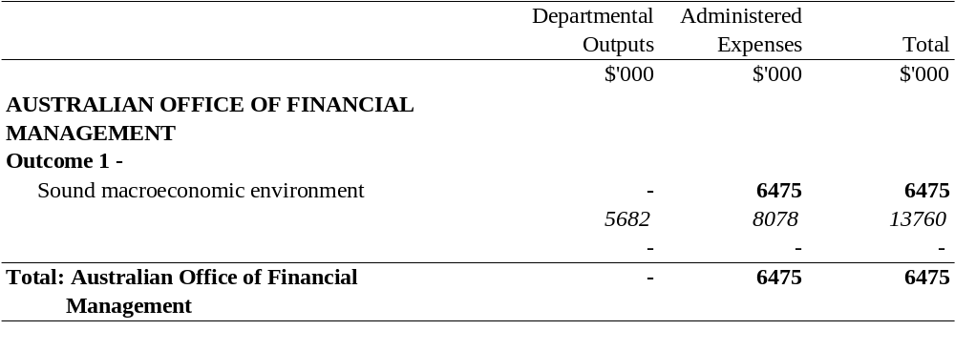

TREASURY PORTFOLIO
Additional Appropriation (bold figures) – 1999-2000
Budget Appropriation (italic figures) – 1999-2000
Estimated Expenses (light figures) – 1998-1999
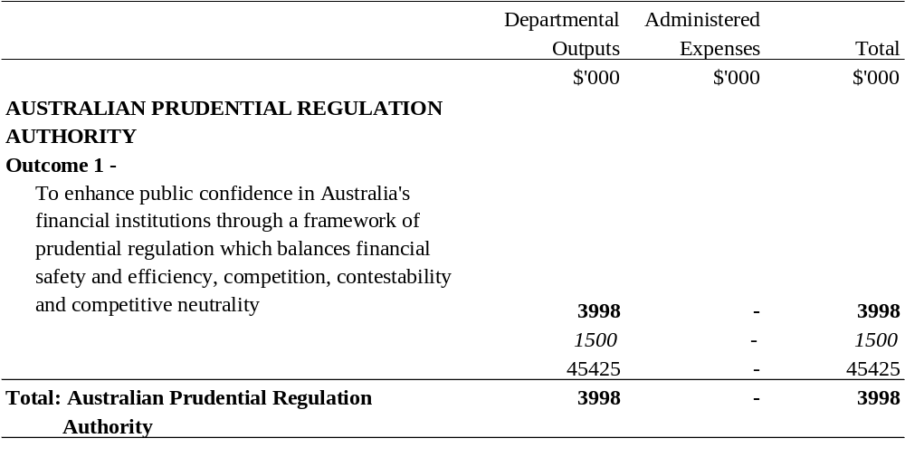

TREASURY PORTFOLIO
Additional Appropriation (bold figures) – 1999-2000
Budget Appropriation (italic figures) – 1999-2000
Estimated Expenses (light figures) – 1998-1999
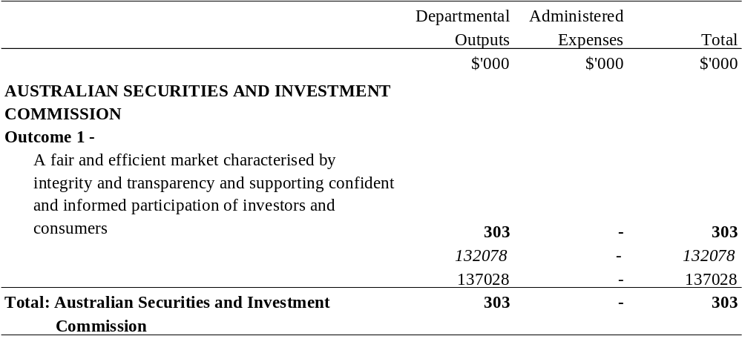

TREASURY PORTFOLIO
Additional Appropriation (bold figures) – 1999-2000
Budget Appropriation (italic figures) – 1999-2000
Estimated Expenses (light figures) – 1998-1999
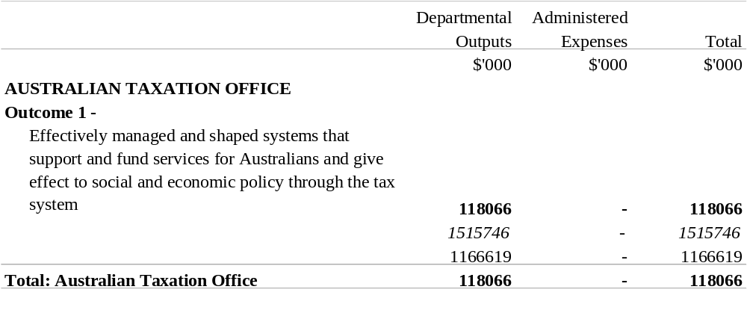

[Minister’s second reading speech made in—
House of Representatives on 8 December 1999
Senate on 15 March 2000]

(212/99)

